# 11

*Chapter A-1*

Chapter 1

Characteristics and applications of pneumatics

*Festo Didactic • TP101*

# 12

*Chapter A-1*

1.1 Pneumatics in review

Pneumatics has long since played an important role as a technology in the performance of mechanical work. It is also used in the development of automation solutions.

In the majority of applications compressed air is used for one or more of the following functions:

* To determine the status of processors (sensors)
* Information processing (processors)
* Switching of actuators by means of final control elements
* Carrying out work (actuators)

To be able to control machinery and installations necessitates the con- struction of a generally complex logic interconnection of statuses and switching conditions. This occurs as a result of the interaction of sen- sors, processors, control elements and actuators in pneumatic or partly pneumatic systems.

The technological progress made in material, design and production processes has further improved the quality and diversity of pneumatic components and thereby contributed to their widely spread use in auto- mation.

The pneumatic cylinder has a significant role as a linear drive unit, due to its

* relatively low cost,
* ease of installation,
* simple and robust construction and
* ready availability in various sizes and stroke lengths.

The pneumatic cylinder has the following general characteristics:

* Diameters 2.5 to 320 mm
* Stroke lengths 1 to 2000 mm
* Available forces 2 to 45000 N at 6 bar
* Piston speed 0.1 to 1.5 m/s

*TP101 • Festo Didactic*

# 20

*Chapter A-1*

The elements in the system are represented by symbols which indicate the function of the element.

*Fig. 1.5*

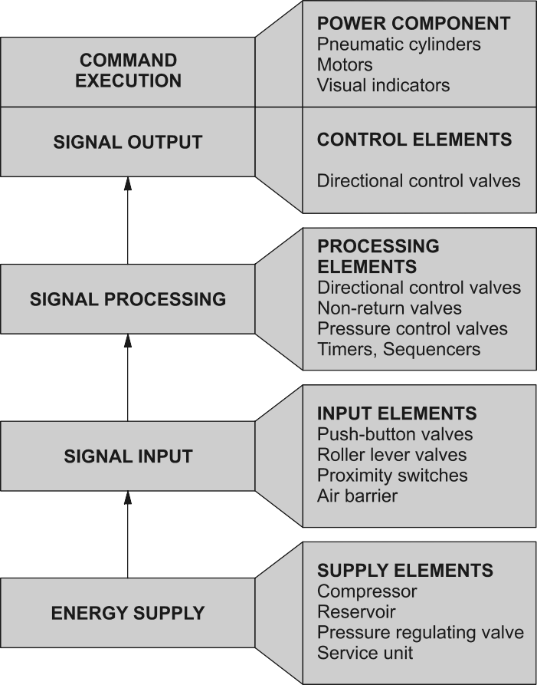

*Pneumatic control system*

*TP101 • Festo Didactic*

# 21

*Chapter A-1*

A directional control valve can be used as an input, processing or control element. The distinguishing feature for the allocation of the individual components to the respective groups of elements is the configuration within a pneumatic system.

*Fig. 1.6*

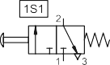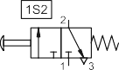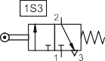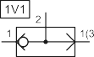

*Circuit diagram and pneumatic elements*







*Festo Didactic • TP101*

# 22

*Chapter A-1*

*TP101 • Festo Didactic*

# 23

*Chapter A-2*

Chapter 2

Components of a pneumatic system

*Festo Didactic • TP101*

# 24

*Chapter A-2*

* 1. Air generation and distribution

The compressed air supply for a pneumatic system should be ade- quately calculated and made available in the appropriate quality.

Air is compressed by the air compressor and delivered to an air distribu- tion system in the factory. To ensure the quality of the air is acceptable, air service equipment is utilised to prepare the air before being applied to the control system.

Malfunctions can be considerably reduced in the system if the com- pressed air is correctly prepared. A number of aspects must be consid- ered in the preparation of the service air:

* Quantity of air required to meet the demands of the system
* Type of compressor to be used to produce the quantity required
* Pressure requirements
* Storage required
* Requirements for air cleanliness
* Acceptable humidity levels to reduce corrosion and sticky operation
* Lubrication requirements, if necessary
* Temperature of the air and effects on the system
* Line sizes and valve sizes to meet demand
* Material selection to meet environmental and system requirements
* Drainage points and exhaust outlets in the distribution system
* Layout of the distribution system to meet demand.

As a rule pneumatic components are designed for a maximum operating pressure of 800-1000 kPa (8 - 10 bar) but in practice it is recommended to operate at between 500-600 kPa (5 and 6 bar) for economic use. Due to the pressure losses in the distribution system the compressor should deliver between 650-700 kPa (6.5 and 7) bar to attain these figures.

A reservoir should be fitted to reduce pressure fluctuations. In some cases, the term ‘receiver’ is also used to describe a reservoir.

The compressor fills the reservoir which is available as a storage tank.

*TP101 • Festo Didactic*

# 25

*Chapter A-2*

The pipe diameter of the air distribution system should be selected in such a way that the pressure loss from the pressurised reservoir to the consuming device ideally does not exceed approx. 10 kPa (0.1 bar). The selection of the pipe diameter is governed by:

* Flow rate
* Line length
* Permissible pressure loss
* Operating pressure
* Number of flow control points in the line

*Fig. 2.1*

*Air distribution system*

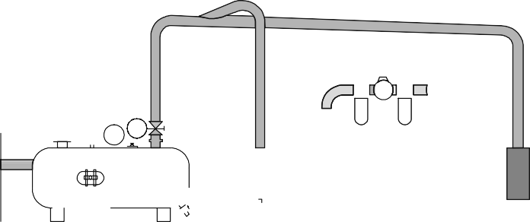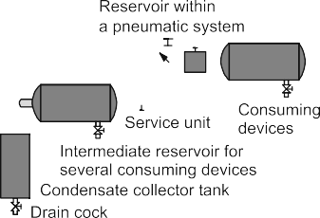

Ring circuits are most frequently used as main lines. This method of installing pressure lines also achieves a constant supply in the case of high air consumption. The pipe lines must be installed in the direction of flow with a gradient of 1 to 2%. This is particularly important in the case of branch lines. Condensate can be removed from the lines at the lowest point.

Any branchings of air consumption points where lines run horizontally should always be installed on the upper side of the main line.

Branchings for condensate removal are installed on the underside of the main line.

Shut-off valves can be used to block sections of compressed air lines if these are not required or need to be closed down for repair or mainte- nance purposes.

*Festo Didactic • TP101*

# 26

*Chapter A-2*

The air service unit is a combination of the following :

* + Compressed air filter (with water separator)
  + Compressed air regulator
  + Compressed air lubricator

However, the use of a lubricator does not need to be provided for in the power section of a control system unless necessary, since the com- pressed air in the control section does not necessarily need to be lubri- cated.

The correct combination, size and type of these elements are deter- mined by the application and the control system demand. An air service unit is fitted at each control system in the network to ensure the quality of air for each individual task.

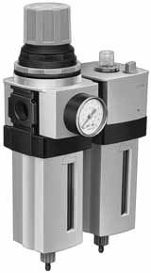*Fig. 2.2*

*Air service unit*



*TP101 • Festo Didactic*

# 27

*Chapter A-2*

The compressed air filter has the job of removing all contaminants from the compressed air flowing through it as well as water which has already condensed. The compressed air enters the filter bowl through guide slots. Liquid particles and larger particles of dirt are separated centri- fugally collecting in the lower part of the filter bowl. The collected con- densate must be drained before the level exceeds the maximum con- densate mark, as it will otherwise be re-entrained in the air stream.

The purpose of the regulator is to keep the operating pressure of the system (secondary pressure) virtually constant regardless of fluctuations in the line pressure (primary pressure) and the air consumption.

The purpose of the lubricator is to deliver a metered quantity of oil mist into a leg of the air distribution system when necessary for the operation of the pneumatic system.

* 1. Valves

The function of valves is to control the pressure or flow rate of pressure media. Depending on design, these can be divided into the following categories:

* Directional control valves
* Input/signalling elements
* Processing elements
* Control elements
* Non-return valves
* Flow control valves
* Pressure control valves
* Shut-off valves

*Compressed air filter*

*Compressed air regulator*

*Compressed air lubricator*

*Festo Didactic • TP101*

# 121

*Section B*

Section B Theory

*Festo Didactic • TP101*

# 122

*Section B*

*TP101 • Festo Didactic*

# 123

*Chapter B-1*

Chapter 1

Fundamentals of pneumatics

*Festo Didactic • TP101*

# 124

*Chapter B-1*

* 1. Physical fundamentals

Air is an abundant gas mixture with the following composition:

* + Nitrogen approx. 78 vol. %
  + Oxygen approx. 21 vol. %

It also contains traces of carbon dioxide, argon, hydrogen, neon, helium, krypton and xenon.

To assist in the understanding of the natural laws as well as the behav- iour of air, the physical dimensions which are employed. The data is taken from the “International System of Units”, SI for short.

*Basic units*

*Derived units*

Quantity Symbol Units

Length L Meter (m)

Mass m Kilogram (kg)

Time t Second (s)

Temperature T Kelvin (K, 0 °C = 273.15 K)

Quantity Symbol Units

Force F Newton (N) = 1 kg • m/s

2

2

Area A Square metre (m )

3

Volume V Cubic metre (m )

3

Flowrate qv (m /s)

Pressure p Pascal (Pa)

2

1 Pa= 1 N/m

5

1 bar = 10 Pa

Newtons Law: Force = mass • acceleration

F = m • a

where a is replaced by the acceleration due to gravity

2

g = 9.81 m/s

Pressure: 1 Pascal is equal to the constant pressure on a surface

2

area of 1 m with the vertical force of 1 N (Newton).

*TP101 • Festo Didactic*

# 125

*Chapter B-1*

The pressure prevailing directly on the earth’s surface is known as at- mospheric pressure (pamb). This pressure is also referred to as reference pressure. The range above this pressure is known as excess pressure range (pe > 0), the range below is referred to as vacuum range (pe < 0). The atmospheric differential pressure pe is calculated according to the formula:

pe = pabs – pamb This is illustrated by the following diagram:

*Fig. 1.1*

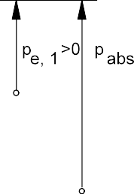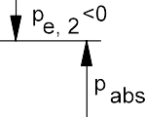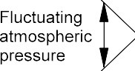

*Air pressure*

Atmospheric pressure does not have a constant value. It varies with the geographical location and the weather.

The absolute pressure pabs is the value relative to pressure Zero - Vac- uum. It is equal to the sum of the atmospheric pressure and the excess pressure or vacuum. In practice, pressure gauges which only indicate the excess pressure are generally used. The absolute pressure value pabs is approximately 100 kPa (1 bar) higher.

Generally, in pneumatics all data concerning air quantity refers to the so- called standard state. According to DIN 1343, the standard state is the status of a solid, fluid or gaseous substance defined by standard tem- perature and pressure.

• Standard temperature Tn = 273.15 K, tn = 0 °C

• Standard pressure pn = 101325 Pa = 1.01325 bar

*Festo Didactic • TP101*

# 126

*Chapter B-1*

* 1. Characteristics of air

A characteristic of air is its minimal cohesion, i.e. the forces between the air molecules are to be disregarded for operating conditions usual in pneumatics. In common with all gases, air has no particular shape. Its shape changes with the slightest resistance, i.e. it assumes the shape of its surroundings.

*Fig. 1.2*

*Boyle-Mariotte’s Law*



  



*Boyle-Mariotte’s Law*

Air can be compressed and it endeavours to expand. The applicable relationship is given in Boyle-Mariottes Law. At constant temperature, the volume of a given mass of gas is inversely proportional to the abso- lute pressure, i.e. the product of absolute pressure and volume is con- stant for a given mass of gas.

p1 • V1 = p2 • V2 = p3 • V3 = Constant

*TP101 • Festo Didactic*

# 127

*Chapter B-1*

The following example illustrates the above principles. Air at atmos- pheric pressure is compressed by an air compressor to 1/7th the vol- ume. What is the gauge pressure of the air assuming a constant tem- perature process ?

p1 • V1 = p2 • V2

*Example calculation*

p 2 = p1

* V1 V2

Note: V2 / V1 = 1/7

p1 = pamb = 100 kPa = 1 bar

p2 = 1 • 7 = 700 kPa = 7 bar absolute

Therefore: pe = pabs – pamb = (700 – 100) kPa = 600 kPa = 6 bar

A compressor that produces 600 kPa must have a compression ratio of 7:1

Air expands by 1/273 of its volume at constant pressure, a temperature of 273 K and a temperature rise of 1 K. According to the Gay-Lussac’s law, the volume of a given mass of gas is proportional to the absolute temperature as long as the pressure does not change.

*Gay-Lussac law*

V1 = T1

V = Volume at T , V = Volume at T

V2 T2

or

1 1 2 2

V *=* Constant T

The volume change ∆V is:

∆V = V2

The following applies for V2:

– V1

= V1

* T2 − T1 T1

2

V2 = V1

+ ∆V = V1

+ V1 (T T1

– T1 )

*Festo Didactic • TP101*

# 128

*Chapter B-1*

The above equations only apply if the temperatures in K are used. In order to be able to calculate in oC, the following formula is to be used:

V2 = V1 +

V1 273°C + T1

(T2

– T1 )

*Example calculation*

* 1. m3 air at temperature T1 = 293 K (20 oC) are heated to T2 = 344 K (71 oC). How much does the air expand?

V = 0.8m3 + 0.8m (344K − 293K)

2

3

293K

V = 0.8m3 + 0.14m3 = 0.94.m3

2

The air has expanded by 0.14 m to 0.94 m .

3

3

If the volume is kept constant during the temperature rise, this results in the following formula for the pressure increase:

p1 *=* T1 p2 T2

or

p *=* Constant T

*General gas equation* The general gas equation is a combination of all three:

p1 • V1 = p 2 • V2

= Constant

T1 T2

In the case of a given mass of gas, the product of pressure and volume divided by the absolute temperature is constant.

This general gas equation results in the previously mentioned laws, if one of the three factors p, V or T is kept constant in each case.

|  |  |  |
| --- | --- | --- |
| * Pressure p constant | ⇒ | isobar changes |
| * Volume V constant | ⇒ | isochore changes |
| * Temperature T constant | ⇒ | isothermal changes |

*TP101 • Festo Didactic*

# 129

*Chapter B-2*

Chapter 2

Air generation and distribution

*Festo Didactic • TP101*

# 130

*Chapter B-2*

2.1 Air preparation

For the continuing performance of control systems and working ele- ments it is necessary to guarantee that the air supply is:

* + - at the required pressure,
    - dry and
    - clean

If these conditions are not fulfilled, then short to medium term degenera- tion of the system will be accelerated. The effect is downtime on the ma- chinery in addition to increased costs for repair or replacement of parts.

The generation of compressed air starts off with compression. The com- pressed air flows through an entire series of components before reach- ing the consuming device. The type of compressor and its location to a lesser or greater degree affect the amount of dirt particles, oil and water which enter into a pneumatic system. The equipment to be considered in the generation and preparation of air include:

* + - Inlet filter
    - Air compressor
    - Air reservoir
    - Air dryer
    - Air filter with water separator
    - Pressure regulator
    - Air lubricator as required
    - Drainage points

Poorly-prepared compressed air will inevitably lead to malfunctions and may manifest itself in the system as follows:

* + - Rapid wear of seals and moving parts in the cylinders and valves
    - Oiled-up valves
    - Contaminated silencers
    - Corrosion in pipes, valves, cylinders and other components
    - Flushing out of lubrication of moving components

In the case of leakage, escaping compressed air may impair the materi- als to be processed (e.g. food).

*TP101 • Festo Didactic*

# 131

*Chapter B-2*

As a rule, pneumatic components are designed for a maximum operat- ing pressure of 800 to 1000 kPa (8-10 bar). Practical experience has shown, however, that approximately 600 kPa (6 bar) should be used for economic operation. Pressure losses of between 10 and 50 kPa (0.1 and 0.5 bar) must be expected due to the restrictions, bends, leaks and pipe-runs, depending on the size of the piping system and the method of layout. The compressor's system should provide at least 650 to 700 kPa (6.5 to 7 bar) for a desired operating pressure level of 600 kPa (6 bar).

2.2 Air compressors

The selection from the various types of compressors available is de- pendent upon quantity of air, pressure, quality and cleanliness and how dry the air should be. There are varying levels of these criteria depend- ing on the type of compressor.



A piston compresses the air drawn in via an inlet valve. The air is passed on via an outlet valve.

Reciprocating compressors are very common and provide a wide range of pressures and delivery rates. For higher pressures multistage com- pression is used with intercooling between each stage of compression.

*Pressure level*

*Fig. 2.1*

*Compressor types*

*Reciprocating piston compressors*

*Festo Didactic • TP101*

# 132

*Chapter B-2*

The optimum range of pressures for reciprocating compressors are ap- proximately:

|  |  |  |
| --- | --- | --- |
| up to 400 kPa | (4 bar) | Single stage |
| up to 1500 kPa | (15 bar) | Double stage |
| over 1500 kPa | (> 15 bar) | Treble or multi stage |

Also, it is possible but not necessarily economic to operate in the follow- ing ranges:

|  |  |  |
| --- | --- | --- |
| up to 1200 kPa | (12 bar) | Single stage |
| up to 3000 kPa | (30 bar) | Double stage |
| over 3000 kPa | (> 30 bar) | Treble or multi stage |

*Diaphragm compressor*

*Rotary piston compressor*

*Screw compressor*

*Flow compressor*

The diaphragm compressor belongs to the reciprocating piston com- pressor group. The compressor chamber is separated from the piston by a diaphragm. The advantage of this is that no oil can enter into the air flow from the compressor. The diaphragm compressor is therefore used where oil is to be excluded from the air supply, for example in the food, pharmaceutical and chemical industries.

The rotary group of compressors use rotating elements to compress and increase the pressure of the air. During the compression process, the compression chamber is continually reduced.

Two screw-shaped shafts (rotors) turn in opposite directions. The mes- hed profile of the two shafts causes the air to flow which is then com- pressed.

These are particularly suitable for large delivery quantities. Flow com- pressors are made in axial or radial form. The air is made to flow by means of one or several turbine wheels. The kinetic energy is converted into pressure energy. In the case of an axial compressor, the air is ac- celerated in the axial direction of flow by means of blades.

*TP101 • Festo Didactic*

# 133

*Chapter B-2*

In order to adapt the delivery quantity of the compressor to the fluctuat- ing demand, it is necessary to regulate the compressor. The delivery quantity is regulated between the adjustable limits for maximum and minimum pressure. There are a number of different types of regulation:

• Idling regulation Relief regulation

Shut-off regulation

Claw regulation

• Part-load control Speed adjustment

Suction throttle control

*Regulation*

• Intermittent control

In the case of relief regulation, the compressor operates against a pres- sure-relief valve. When the set pressure is reached, the pressure-relief valve opens and the air is exhausted to atmosphere. A non-return valve prevents the emptying of the tank. This type of regulator is only used for very small installations.

With shut-off regulation the suction side is shut off. The compressor cannot take in air. This type of regulation is mainly used in the case of rotary piston compressors.

With larger piston compressors, claw regulation is used. A claw holds the suction valve open; the compressor cannot compress any air.

In the case of speed adjustment, the speed of the drive motor of the compressor is controlled dependent on the pressure reached.

With suction throttle control, control is effected by means of a restrictor in the suction connection of the compressor.

With this type of control, the compressor assumes the operational condi- tions ‘full load’ and ‘normal‘. The drive motor of the compressor is switched off when pmax is reached, and switched on when pmin is reached.

It is recommended that a duty cycle of approx. 75 % is achieved for a compressor. To do so, it is necessary to determine the average and maximum air requirement of a pneumatic system and to select the com- pressor on the basis of this. If it is anticipated that the air requirement will increase as a result of system expansions, then the compressor air supply section should be designed larger, since subsequent expansion is associated with high costs.

*Idling regulation*

*Part-load control*

*Intermittent control*

*Duty cycle*

*Festo Didactic • TP101*

# 134

*Chapter B-2*

2.3 Reservoirs

A reservoir is configured downstream of a compressor to stabilise com- pressed air. A reservoir compensates the pressure fluctuations when the compressed air is taken from the system. If the pressure in the reservoir drops below a certain value, the compressor will compensate until the set higher value is reached again. This has the advantage that the com- pressor does not need to operate continuously.

The large surface area of the reservoir cools the air. Thus, a portion of the moisture in the air is separated directly from the reservoir as water, which has to be regularly drained via a drain cock.

*Fig. 2.2*

*Reservoir*

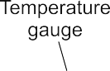

The size of a compressed air reservoir depends on the:

• Delivery volume of the compressor

• Air consumption for the applications

• Network size (any additional requirements)

• Type of compressor cycle regulation

• Permissible pressure drop in the supply network

*TP101 • Festo Didactic*

# 135

*Chapter B-2*





|  |  |  |
| --- | --- | --- |
| Delivery volume | qL | 3  = 20 m /min |
| Switching cycles per hour | z | = 20 1/h |
| Differential pressure | ∆p | = 100 kPa (1 bar) |

Result: Reservoir size VB = 15 m (refer to the chart)

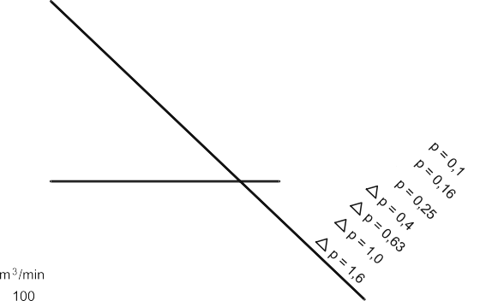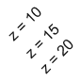

3

*Volume of reservoir*

*Fig. 2.3*

*Diagram: Determining the volume of a reservoit*

*Example*

*Festo Didactic • TP101*

# 136

*Chapter B-2*

* 1. Air dryers

Condensate (water) enters into the air network through the air intake of the compressor. The accumulation of condensate depends largely on the relative air humidity. The relative air humidity is dependent on the air temperature and the weather situation.

The absolute humidity is the mass of water vapour, actually contained in

3

one m of air. The saturation quantity is the mass of water vapour, which

3

one m of air can absorb at the respective temperature.

The following formula applies if the relative air humidity is specified in percent:

Relativehumidity = absolute humidity • 100%

saturation quantity

Since the saturation quantity is dependent on temperature, the relative humidity changes with the temprature, even if the absolute humidity re- mains constant. If the dew point is reached, the relative humidity in- creases to 100%.

*Dew point*

*Pressure dew point*

The dew point temperature is the temperature at which relative humidity is 100%. The lower the dew point the more the water will condense and reduce the amount entrapped in the air.

The service life of pneumatic systems is considerably reduced if exces- sive moisture is carried through the air system to the components. Therefore it is important to fit the necessary air drying equipment to re- duce the moisture content to a level which suits the application and the components used. There are three auxiliary methods of reducing the moisture content in air:

* + Low temperature drying
  + Adsorption drying
  + Absorption drying

To be able to compare different types of drying systems, the operating pressure of the system must be taken into account. The term ‘pressure dew point’ is used in this context. The pressure dew point is the air tem- perature reached during drying at operating pressure.

*TP101 • Festo Didactic*

# 137

*Chapter B-2*

The pressure dew point of the dried air should be approx. 2 to 3 °C un- der the coolest ambient temperature.

The additional cost of installing air drying equipment can be amortised over a short period due to the reduction in maintenance costs, reduced downtime and increased reliability of the system.

The most common type of dryer today is the refrigeration dryer. With refrigerated drying, the compressed air is passed through a heat- exchanger system through which a refrigerant flows. The aim is to re- duce the temperature of the air to a dew point which ensures that the water in the air condenses and drops out in the quantity required.

The air entering into the refrigeration dryer is pre-cooled in a heat ex- changer by the escaping cold air. It is then cooled in the cooling unit to temperatures between + 2 and + 5 °C. The dried compressed air is fil- tered. Before the compressed air is output into the network, the air is heated to bring the air back to ambient conditions.

Using refrigeration methods, it is possible to achieve dew points of be- tween + 2 and + 5 °C.

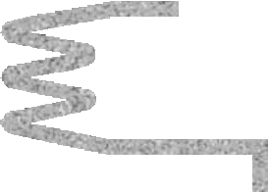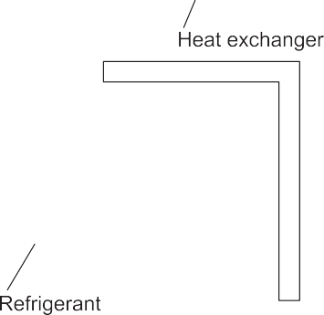

*Low temperature drying*

*Fig. 2.4*

*Low temperature drying*

*Festo Didactic • TP101*

# 138

*Chapter B-2*

*Adsorption dryers*

*Fig. 2.5*

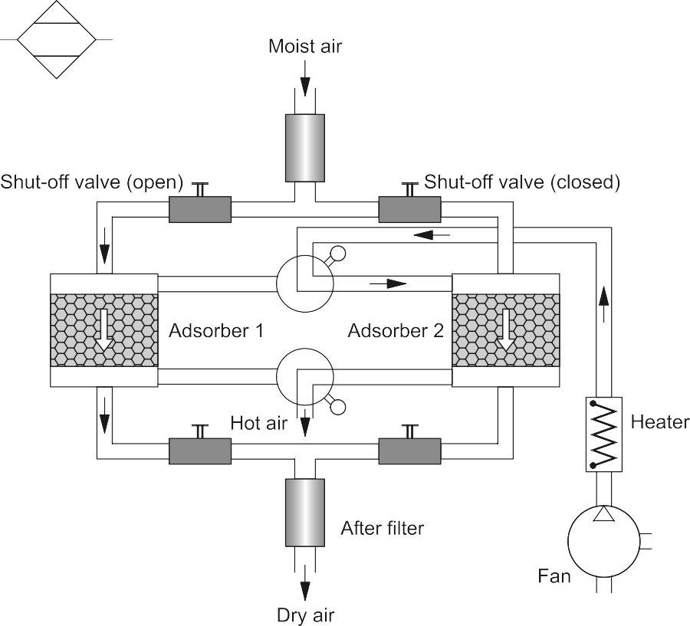

*Adsorption dryers*

Adsorption: water is deposited on the surface of solids.

The drying agent is a granular material (gel) consisting almost entirely of silicon dioxide.

Usually two tanks are used. When the gel in one tank is saturated, the air flow is switched to the dry, second tank and the first tank is regener- ated by hot-air drying.

The lowest equivalent dew points (down to – 90 °C) can be achieved by means of adsorption drying.

*TP101 • Festo Didactic*

# 139

*Chapter B-2*

Absorption: A solid or liquid substance bonds a gaseous substance.

Absorption drying is a purely chemical process. Absorption drying is not of major significance in present-day practice, since the operating costs are too high and the efficiency too low for most applications.

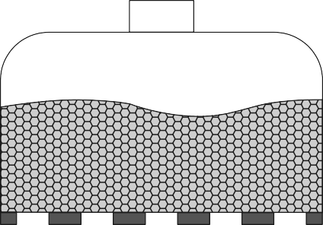



*Absorption dryers*

*Fig. 2.6*

*Absorption dryers*

 

Oil vapour and oil particles are also separated in the absorption dryer. The moisture in the compressed air forms a compound with the drying agent in the tank. This causes the drying agent to break down; it is then discharged in the form of a fluid at the base of the tank.

The mixture must be regularly drained and the fluxing agent must be regularly replaced.

The features of the absorption process are :

• Simple installation of the equipment

• Low mechanical wear because there are no moving parts in the dryer

• No external energy requirements.

*Festo Didactic • TP101*

# 140

*Chapter B-2*

A dust filter must be provided downstream of the dryer to catch any en- trained fluxing agent dust.

Pressure dew points below 0 °C can be reached.

*Fig. 2.7*

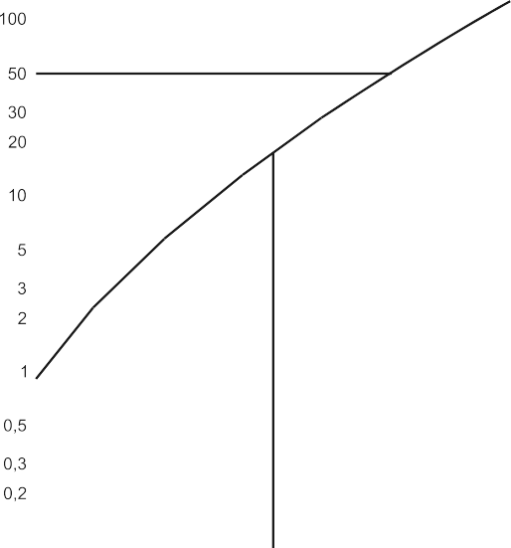

*Dew point chart*





*TP101 • Festo Didactic*

# 141

*Chapter B-2*

Suction capacity 1000 m /h

3

Absolute pressure 700 kPa (7 bar) Compressed volume per hour 143 m

3

Suction temperature 293 K (20 °C) Temperature after compression 313 K (40 °C) Relative humidity 50%

Quantity of water prior to compression:

The following water content is obtained at 293 K (20 °C): 100% = 17.3 g/m

3

3

Therefore 50% = 8.65 g/m

3

3

*Example calculation*

Results in 8.65 g/m • 1000 m /h = 8650 g/h

Quantity of water after compression:

The following saturation quantity is obtained at 313 K (40 °C):

3

51.1 g/m

3

3

Results in 51.1 g/m • 143 m /h = 7307 g/h

The separated quantity of water downstream of the compressor is there- fore:

8650 g/h - 7307 g/h = 1343 g/h.

* 1. Air distribution

In order to ensure reliable and trouble-free air distribution, a number of points must be observed. This includes primarily the correct sizing of the pipe system, but also the pipe material, flow resistances, pipe layout and maintenance.

In the case of new installations, allowance should be made in all cases for extension of the compressed-air network. The main line size deter- mined by current requirements should therefore be increased to include an appropriate safety margin. Plugs and shut-off valves allow extension to be carried out easily at a later time.

Losses occur in all pipes due to flow resistances. Flow resistances are represented by restrictions, bends, branches and fittings. These losses must be made up by the compressor. The pressure drop in the entire network should be as small as possible.

*Sizing pipe systems*

*Festo Didactic • TP101*

# 142

*Chapter B-2*

To be able to calculate the pressure drop the total pipe length must be known. For fittings, branches and bends, equivalent pipe lengths are determined. The choice of the correct internal diameter is also depend- ent on the operating pressure and delivery of the compressor. Selection is best made with the aid of a nomograph.

*Flow resistances*

*Pipe material*

Any influence or change of direction within the pipe system means inter- ference with the air flow and thus an increase of the flow resistance. This leads to a continuous pressure drop along the pipe system. Since branches, bends, adapters and fittings are required in all compressed-air networks, this pressure drop cannot be avoided but can be considerably reduced by routing pipes favourably, choosing suitable materials and assembling the fittings correctly.

The choice of suitable pipe material is determined by the requirements placed on a modern compressed-air network:

* Low pressure losses
* Freedom from leaks
* Resistant to corrosion
* Capability of system expansion.

In selecting a suitable pipe material, consideration must be given not only to price per metre run but also to another major factor, the installa- tion costs. These are lowest with plastics. Plastic pipes can be joined 100% airtight by means of adhesives or fittings and can easily be ex- tended.

Copper, steel and iron pipes have a lower purchase price but must be brazed, welded or joined by means of threaded connectors; if this work is not carried out correctly, swarf, scale, welding particles or sealing ma- terials may be introduced into the system. This may lead to major mal- functions. For small and medium diameters, plastic pipes are superior to other materials as regards price, assembly, maintenance and ease of extension.

*TP101 • Festo Didactic*

# 143

*Chapter B-2*

Pressure fluctuations in the network make it necessary to ensure that the pipes are mounted securely in order to avoid leakages at screwed and brazed connections.

*Fig. 2.8*

*Air supply system*

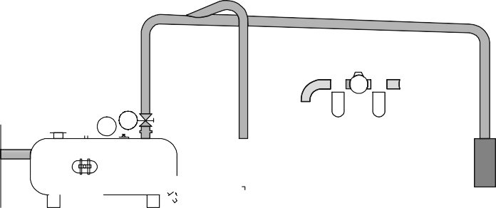

Apart from correct sizing of the piping and the quality of the pipe mate- rial, correct pipe layout is the decisive factor in determining the economic operation of the compressed-air system. Compressed air is fed into the system at intervals by the compressor. It is often the case that consump- tion at consuming devices rises for only a short time. This may lead to unfavourable conditions in the compressed-air network. It is therefore recommended that the compressed-air network should be produced in the form of a ring main. A ring main ensures largely constant pressure conditions.

*Piping layout*

*Fig. 2.9*

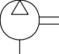

*Ring circuit*



*Festo Didactic • TP101*

# 144

*Chapter B-2*

For ease of maintenance, repair or extension of the network without in- terfering with the overall air supply, it is advisable to sub-divide the net- work into individual sections. Branches with T-pieces and manifolds with plug-in couplings make this possible. It is advisable to fit the branch lines with standard ball valves or shut off valves.

*Fig. 2.10*

*Interconnected network*

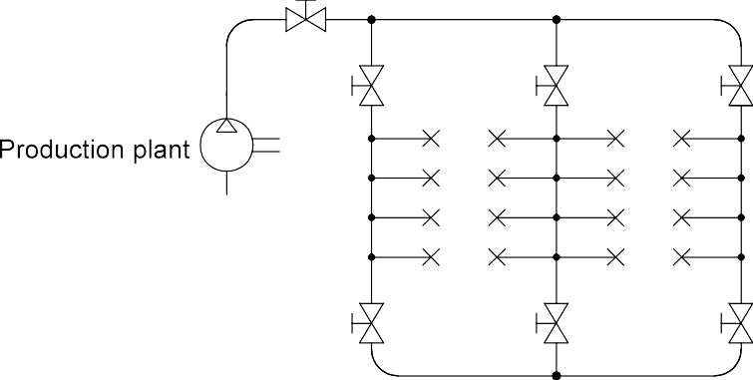

Despite the best water separation in the pressure generating system, pressure drops and external cooling may produce condensate in the pipe system. In order to discharge this condensate, the pipes should be inclined 1-2%; this can also be carried out in stages. The condensate can then be discharged from the system via water separators at the low- est point.

2.6 Service unit

The individual functions of compressed air preparation, i.e. filtering, regulating and lubricating, can be fulfilled by individual components. These functions have often been combined into one unit, i.e. the service unit. Service units are connected upstream of all pneumatic systems.

Generally, the use of a lubricator is not necessary in advanced systems. This is to be used for specific requirements only, primarily in the power section of a system. Compressed air in a control section should not be lubricated.

*TP101 • Festo Didactic*

# 145

*Chapter B-2*

Condensed water, contamination and excess oil can lead to wear on the moving parts and seals of pneumatic components. These substances can escape as a result of leakage. Without the use of filters, for exam- ple, products to be processed in the food, pharmaceutical or chemical industries could become contaminated and therefore rendered useless.

*Compressed air filter*

*Fig. 2.11*

*Compressed air filter*

Baffle

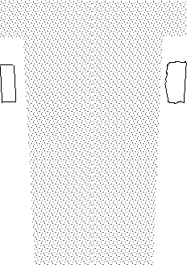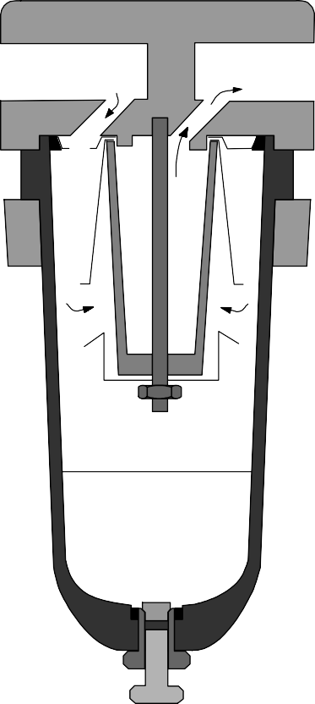

Filter

Condensate

Filter bowl

Drain screw

The selection of the correct filter plays an important role in determining the quality and performance of the working system which is to be sup- plied with compressed air. One characteristic of compressed-air filters is the pore size. The pore size of the filter element indicates the minimum particle size which can be filtered out of the compressed air. The col- lected condensate must be drained before the level exceeds the maxi- mum condensate mark otherwise it will be re-introduced in the air stream.

*Festo Didactic • TP101*

# 146

*Chapter B-2*

If a large amount of condensate accumulates, it is advisable to fit an automatic drain in place of the manually operated drain cock. However, in such cases, the cause of the accumulated condensate is to be estab- lished. For example, an unsuitable pipe layout may be the cause of the condensate accumulation.

The automatic drain uses a float to determine the level of condensate in the bowl and when the limit is reached a control piston opens a valve seat that ejects the condensate under air pressure via a drain line. If the float reaches the minimum level of condensate, the seat valve is closed and the process stopped. The filter bowl can also be emptied manually.

The compressed air passes through the filter from left to right and is fed through a baffle plate in the filter bowl. The effect of the baffle plate is that the air is caused to rotate, and the heavier dust particles and water droplets are spun by centrifugal force against the inner wall of the filter bowl. They then run down the wall of the housing and collect in the filter bowl. The air which has been pre-cleaned in this way then passes through the filter element, which filters out the smaller dirt particles. The filter element in this case consists of a highly-porous sintered material. The degree of separation depends on the pore size of the filter element used. Inserts with different pore sizes are available. The usual pore sizes are between 5 microns and 40 microns.

A further important characteristic of compressed-air filters is the degree of separation, or efficiency, which indicates the percentage of particles of a particular size which can be separated out. The efficiency is quoted for a particle size, e.g. efficiency of 99.99% for 5 microns. With micro filters, 99,999% of particles greater than 0.01 µm can be filtered.

The filtration action of a compressed-air filter is retained, even after long service and with heavy contamination. However, under these conditions, the pressure drop becomes disproportionately high and the filter be- comes an energy-waster.

In order to recognise the correct time to change the filter element, a vis- ual inspection or a measurement of the pressure difference across the filter should be carried out.

*TP101 • Festo Didactic*

# 147

*Chapter B-2*

Depending on the nature of the compressed air available, the air con- sumption of the components and the filter size, compressed-air filters require a greater or lesser amount of maintenance work. Maintenance work means the following :

• Replacing or cleaning the filter element

• Draining the condensate

When cleaning is required, the manufacturer's specifications must be observed concerning the cleaning agents to be used.

The compressed air generated by the compressor will fluctuate. Changes in the pressure level in the pipe system can adversely affect the switching characteristics of valves, the running times of cylinders and the timing characteristics of flow control and memory valves.

A constant pressure level is thus a prerequisite for the trouble-free op- eration of a pneumatic control. In order to provide constant pressure conditions, regulators are fitted in a central position in the compressed air network to ensure that there is a constant supply pressure (secon- dary pressure) irrespective of the pressure fluctuations in the main loop (primary pressure). The pressure reducer or pressure regulator is fitted downstream of the compressed air filter and has the task of keeping the operating pressure constant, regardless of pressure fluctuations or air consumption in the system. The air pressure should be matched to indi- vidual requirements upstream of each plant section.

The system pressure which has proved in practice to be the best eco- nomic and technical compromise between compressed-air generation and the efficiency of the components is approximately:

• 600 kPa (6 bar) in the power section and

• 300 to 400 kPa (4 bar) in the control section.

A higher operating pressure would lead to inefficient energy utilisation and increased wear, whereas a lower operating pressure would lead to poor efficiency, particularly in the power section.

*Maintenance*

*Compressed air regulators*

*Festo Didactic • TP101*

# 148



*Chapter B-2*

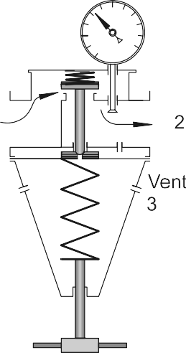*Fig. 2.12*

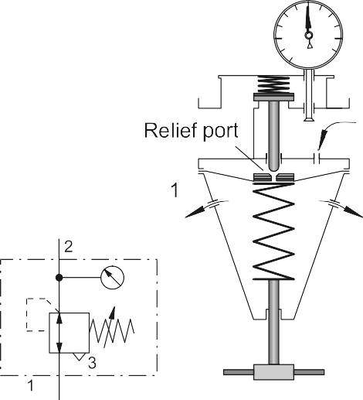

*Pressure regulator:*

*relieving*







*Operational principle*

The input pressure (primary pressure) at the pressure regulator must always be higher than the output pressure (secondary pressure). The pressure is regulated by a diaphragm. The output pressure acts on one side of the diaphragm and a spring acts on the other side. The spring force can be adjusted by means of an adjusting screw.

When the output pressure increases for example during cylinder load changes, the diaphragm moves against the spring force causing the outlet cross-sectional area at the valve seat to be reduced or closed en- tirely. The centrepiece of the diaphragm then opens and the compressed air can flow to atmosphere through the vent holes in the housing.

When the output pressure decreases the spring force opens the valve. Regulation of the preset output pressure is thus a continual opening and closing of the valve seat caused by the flow of air. The operating pres- sure is indicated on a gauge.

*TP101 • Festo Didactic*

# 149

*Chapter B-2*

*Fig. 2.13*



*Pressure regulator: non-relieving*



If no air is drawn off on the secondary side, the pressure rises and presses the diaphragm against the compression spring. The outlet cross-sectional area at the vlave seat is reduced or closed and the flow of air is reduced or cut off entirely. The compressed air can continue to flow only when air is drawn off on the secondary side.

As a rule the compressed air which is generated should be dry, i.e. free of oil. For some components lubricated air is damaging, for others, it is undesirable, but for power components it may in certain cases be nec- essary. Lubrication of the compressed air should therefore always be limited to the plant sections which require lubrication. For this purpose, mist lubricators are fitted to feed the compressed air with specially se- lected oils. Oils which are introduced into the air from the compressor are not suitable for the lubrication of control system components.

*Operational principle*

*Compressed air lubricator*

*Festo Didactic • TP101*

# 150

*Chapter B-2*

As a general principle cylinders with heat-resistant seals must not be supplied with lubricated compressed air, since the special grease which forms the original lubrication would be washed out.

If systems, which have been operated with lubrication, are converted to unlubricated compressed air, the original lubrication of the valves and cylinders must be renewed, since these may have been flushed out in some instances.

*Fig. 2.14*

*Lubricator*

Viaduct

Drip chamber

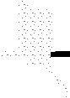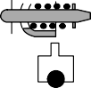

Duct

Check valve

Valve restriction

Ball seat

Riser

Oil

Lubrication of the compressed air by means of mist lubricators may be necessary in certain cases:

• Where extremely rapid oscillating motions are required

• With cylinders of large diameter, lubricators should where possible be installed only directly upstream of the consuming cylinders

*TP101 • Festo Didactic*

# 151

*Chapter B-2*

The following problems may occur as a result of excessive lubrication:

• Malfunction of components

• Increased environmental problems

• Seizing of components after prolonged downtime

The compressed air passing through the lubricator causes a pressure drop between the oil reservoir and the upper part of the lubricator. The pressure difference is sufficient to force the oil upwards through a duct where it then drips into a nozzle which can be seen through an inspec- tion glass. Here the oil is atomised and taken up by the air stream to a greater or lesser extent.

It is possible to check the oil dosage as follows:

A reference value for oil dosage is a quantity of 1 to 10 droplets per cu- bic metre of compressed air. The correct metering can be checked as follows: A piece of white cardboard should be held at a distance of ap- proximately 10 cm from the exhaust port of the power valve of the cylin- der which is furthest away from the lubricator. If the system is then al- lowed to operate for some time, it should be possible to see only a pale yellow colour on the cardboard. Dripping oil is a clear sign of over- lubrication.

Up to a few years ago, the general view was that the oil discharged by the compressor could be used as a lubricant for the power components. Now it has been recognised that this is not the case. As the level of heat produced in the compressor is very high, the oil is carbonised and the oil vapour exhausted. This leads to an abrasive action on cylinders and valves, and service is considerably reduced.

A further problem is that oil is deposited on the inner walls of the pipes and is eventually absorbed in an uncontrolled way into the air flow. This fact alone makes controlled and effective distribution impossible. A pipe which has become contaminated in this way can no longer be cleaned without dismantling. A further disadvantage is gumming, which means that after a system has been at a standstill for some time (after week- ends and public holidays), lubricated components do not function cor- rectly.

*Operational principle*

*Checking the oil dosage*

*Removing oil*

*Festo Didactic • TP101*

# 152

*Chapter B-2*

Lubrication of compressed air should be restricted solely to the system components to be supplied. The best way of supplying oil is to install lubricators directly upstream of the consuming devices. Components with auto-lubrication should be selected for the control section of a pneumatic system.

The basic rule should therefore be: Preparation of compressed air in oil- free form.

The following points should be observed in everyday practice:

• As far as possible compressor oils should be prevented from enter- ing the compressed-air network (oil separators should be fitted)

• For operation fit components which can also function with non- lubricated compressed air

• Once a system has been operated and run-in with oil, the lubrication must be continued since the original lubrication of the components will have been flushed away by the oil.

*Service unit*

*Fig. 2.15*

*Service unit: principle of operation*

The following should be observed with service units:

* The total air throughput in m3/h determines the size of the unit. If the air throughput is too high, a large pressure drop occurs in the units. The values specified by the manufacturer should be observed.
* The working pressure may not exceed the value stated on the ser- vice unit. The ambient temperature should not exceed 50 °C (maxi- mum values for plastic bowls).



*TP101 • Festo Didactic*

# 153

*Chapter B-2*

*Fig. 2.16*



*Service unit: symbols*









The following routine service measures are necessary on a regular ba- sis.

• Compressed air filter:

The condensate level has to be checked regularly, as the level indi-

cated in the sight glass must not be exceeded. If the level is ex- ceeded, this can result in the accumulated condensate being drawn into the air supply lines. The excess condensate can be drained us- ing the drain cock on the sight glass. The filter cartridge must also be checked for contamination and cleaned or replaced if necessary.

• Compressed air regulator:

This requires no servicing, provided it is preceded by a compressed

air filter.

• Compressed air lubricator:

If fitted check the oil level in the sight glass and top up, if necessary,

to the level indicated. The plastic filter and lubricator bowl must not be cleaned with trichloroethylene. Only mineral oils may be used for the lubricator.

*Maintenance of air service units*

*Festo Didactic • TP101*

# 154

*Chapter B-2*

*TP101 • Festo Didactic*

# 155

*Chapter B-3*

Chapter 3

Actuators and output devices

*Festo Didactic • TP101*

# 156

*Chapter B-3*

An actuator is an output device for the conversion of supply energy into useful work. The output signal is controlled by the control system, and the actuator responds to the control signals via the control element. Other types of output devices are used to indicate the status of the con- trol system or actuators, e.g. a pneumatically actuated visual display.

The pneumatic actuator can be described under two groups, linear and rotary :

• Linear motion

– Single-acting cylinders

– Double-acting cylinders

• Rotary motion

– Air motor

– Rotary cylinders

– Rotary actuator

3.1 Single-acting cylinders

With single-acting cylinders compressed air is applied on only one side of the piston face. The other side is open to atmosphere. The cylinder can produce work in only one direction. The return movement of the pis- ton is effected by a built-in spring or by the application of an external force. The spring force of the built-in spring is designed to return the piston to its start position with a reasonably high speed under no load conditions.

*Fig.3.1*

*Single-acting cylinder*



*TP101 • Festo Didactic*

# 157

*Chapter B-3*

For single-acting cylinders with built-in spring, the stroke is limited by the natural length of the spring. Single-acting cylinders are therefore only available in stroke lengths of up to approximately 80 mm.

The construction and simplicity of operation of the single-acting cylinder makes it particularly suitable for compact, short stroke length cylinders for the following types of applications:

• Transferring

• Branching

• Converging

• Allocating

• Clamping

• Ejecting

The single-acting cylinder has a single piston seal which is fitted on the air supply side. Sealing is by a flexible material that is embedded in a metal or plastic piston (Perbunan). During motion, the sealing edges slide over the cylinder bearing surface.

There are varying designs of single-acting cylinders including:

• Diaphragm cylinder

• Rolling diaphragm cylinder

With a diaphragm cylinder, a built-in diaphragm made of rubber, plastic or metal performs the task of the piston. The piston rod is mounted cen- trally on the diaphragm. There is no sliding seal, but merely friction as a result of the tensile stress of the diaphragm. They are used in short stroke applications, for clamping, embossing and lifting operations.

*Construction*

*Fig. 3.2*

*Diaphragm cylinder*



*Festo Didactic • TP101*

# 158

*Chapter B-3*

3.2 Double-acting cylinders

*Fig. 3.3*

*Double-acting cylinder*



The construction principle of a double-acting cylinder is similar to that of the single-acting cylinder. However, there is no return spring, and the two ports are used alternatively as supply and exhaust ports. The dou- ble-acting cylinder has the advantage that the cylinder is able to carry out work in both directions of motion. Thus, installation possibilities are universal. The force transferred by the piston rod is somewhat greater for the forward stroke than for the return stroke as the effective piston surface is reduced on the piston rod side by the cross-sectional area of the piston rod.

*Design development*

Pneumatic cylinders have developed in the following directions:

* Contactless sensing requirements - hence the use of magnets on pistons for reed switch operation
* Stopping heavy loads
* Rodless cylinders where space is limited
* Alternative manufacturing materials such as plastic
* Protective coatings against harsh environments, i.e. acid-resistant
* Increased load carrying capacity
* Robotic applications with special features such as non-rotating pis- ton rods, hollow piston rods for vacuum suction cups

*TP101 • Festo Didactic*

# 159



*Chapter B-3*

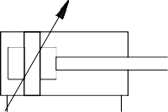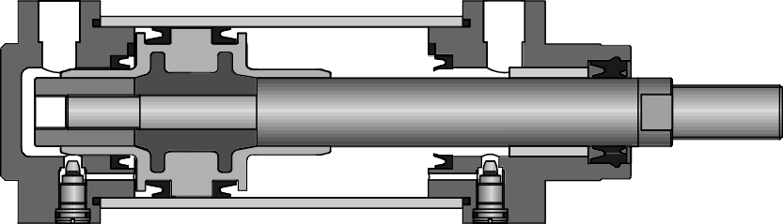If large masses are moved by a cylinder, cushioning is used in the end positions to prevent sudden damaging impacts. Before reaching the end position, a cushioning piston interrupts the direct flow path of the air to the outside. Instead a very small and often adjustable exhaust aperture is open. For the last part of the stroke the cylinder speed is progressively reduced. If the passage adjustment is too small, the cylinder may not reach the end position due to the blockage of air.

With very large forces and high accelerations extra measures must be taken such as external shock absorbers to assist the load deceleration.

To achieve correct deceleration:

• the regulating screw should first be screwed in fully and

• backed off in order to allow the adjustment to be increased slowly to the optimum value.

*Cylinder with end position cushioning*

*Fig. 3.4*

*Double-acting cylinder with end position cushioning*

*Festo Didactic • TP101*

# 160



*Chapter B-3*

*Tandem double-acting cylinder*

*Fig. 3.5*

*Tandem double-acting cylinder*

*Cylinders with through piston rod*

*Fig. 3.6*

*Cylinders with through piston rod*

The tandem cylinder incorporates the features of two double-acting cyl- inders which have been joined to form a single unit. By this arrangement and with the simultaneous loading of both pistons, the force on the pis- ton rod is almost doubled. This design is suitable for such applications where a large force is required but the cylinder diameter is restricted.

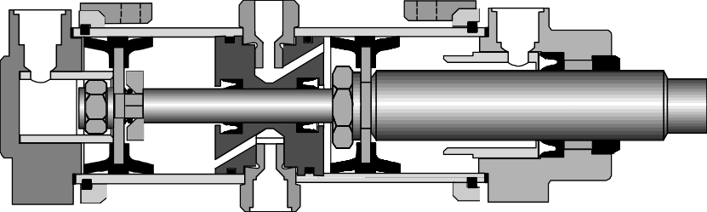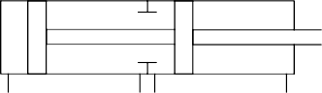This cylinder has a piston rod on both sides, which is a through piston rod. The guide of the piston rod is better, as there are two bearing points. The force is identical in both directions of movement.

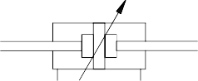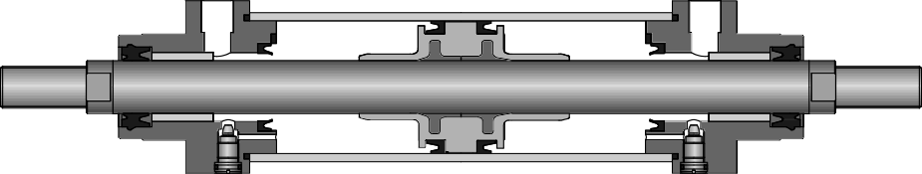The through piston rod can be hollow, in which case it can be used to conduct various media, such as compressed air. A vacuum connection is also possible.

*TP101 • Festo Didactic*

# 161

*Chapter B-3*

The multiposition cylinder consists of two or several double-acting cylin- ders, which are interconnected. The individual cylinders advance when pressure is applied. In the case of two cylinders with different stroke lengths, four positions are obtained.



The pressure forces of pneumatic cylinders are limited. One cylinder for high kinetic energy is the impact cylinder. The high kinetic energy is achieved by means of increasing the piston speed. The piston speed of the impact cylinder is between 7.5 m/s and 10 m/s. However, in the case of large forming distances, the speed is rapidly reduced. The impact cylinder is therefore not suitable for large forming distances.

*Multiposition cylinders*

*Fig. 3.7*

*Multiposition cylinders*

*Impact cylinders*

*Fig. 3.8*

*Impact cylinders*

 

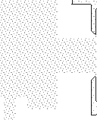



*Festo Didactic • TP101*

# 162

*Chapter B-3*

Actuation of a valve causes pressure to build up in chamber A. If the cylinder moves in direction Z, the full piston surface is exposed. The air from chamber A is able to flow quickly via the large cross section C. The piston is greatly accelerated.

*Rotary cylinders*

*Fig. 3.9*

*Rotary cylinders*

With this design of double-acting cylinder, the piston rod has a gear- tooth profile. The piston rod drives a gear wheel, and a rotary movement results from a linear movement. The range of rotation varies from 45o, 90o, 180o, 270o to 360o. The torque is dependent on pressure, piston surface and gear ratio; values of roughly up to 150 Nm are possible.



*TP101 • Festo Didactic*

# 163

*Chapter B-3*

With a rotary actuator, force is transmitted direct to the drive shaft via a vane. Angular displacement is infinitely adjustable from 0o to approx. 180o. Torque should not exceed 10 Nm.

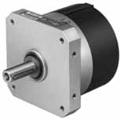

Design features of pneumatic rotary actuators:

• Small and robust

• Available with contactless sensing

• Adjustable for angular displacement

• Easy to install

*Rotary actuator*

*Fig. 3.10*

*Rotary actuator*

*Festo Didactic • TP101*

# 164

*Chapter B-3*

3.3 Rodless cylinders

Three different operational principles are used for the construction of rodless cylinders:

• Band or cable cylinder

• Sealing band cylinder with slotted cylinder barrel

• Cylinder with magnetically coupled slide

Compared with conventional double-acting cylinders, rodless cylinders are shorter in length. This eliminates the risk of a buckling piston rod and movement can take place over the entire stroke length. The cylinder design can be used for extremely large cylinder lengths of up to 10 m. Devices, loads etc, can be attached directly to the mounting surface pro- vided for this on a carriage or outer slide. The force is identical in both directions of movement.

*Band cylinder*

*Fig. 3.11*

*Band cylinder*

In the case of band cylinders, the piston force is transferred to a slide via a circulating band. When leaving the piston chamber, the band passes through a seal. In the cylinder caps, the band is reversed via guide roll- ers. Wipers ensure that no contamination reaches the guide rollers via the band.

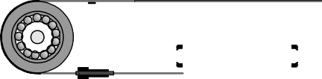

*TP101 • Festo Didactic*

# 165

*Chapter B-3*

With this type, the cylinder barrel is provided with a slot across the entire length. The force is transmitted via a slide permanently connected to the piston. The connection from piston to slide is directed outwards via the slotted cylinder barrel. The slot is sealed by means of a sealing band, which seals the inside of the slot. The sealing band is guided between the piston seals and passed under the slide. A second cover strip covers the slot from the outside in order to prevent the ingress of dirt.

*Sealing band cylinder*

*Fig. 3.12*

*Sealing band cylinder*



*Festo Didactic • TP101*

# 166



*Chapter B-3*

*Cylinder with magnetic coupling*

*Fig. 3.13*

*Cylinder with magnetic coupling*

This double-acting pneumatic linear actuator (rodless cylinder) consists of a cylindrical barrel, a piston and 2 slide. The piston in the cylinder is freely movable according to pneumatic actuation, but there is no positive external connection. The piston and the slide are fitted with a set of an- nular permanent magnets. Thus, a magnetic coupling is produced be- tween slide and piston. As soon as the piston is moved by compressed air the slide moves synchronously with it. The cylinder barrel is hermeti- cally sealed from the outer slide since there is no mechanical connec- tion. There are no leakage losses.

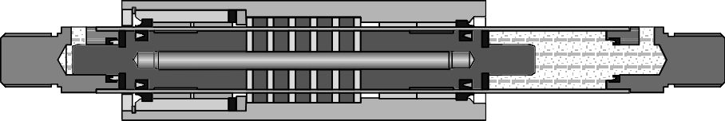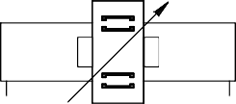*TP101 • Festo Didactic*

# 167

*Chapter B-3*

* 1. Cylinder construction

The cylinder consists of a cylinder barrel, bearing and end cap, piston with seal (double-cup packing), piston rod, bearing bush, scraper ring, connecting parts and seals.

*Fig. 3.14*

*Design of a pneumatic cylinder with end position cushioning*





The cylinder barrel (1) is usually made of seamless drawn steel tube. To increase the life of the sealing components, the bearing surfaces of the cylinder barrel are precision-machined. For special applications, the cyl- inder barrel can be made of aluminium, brass or steel tube with hard- chromed bearing surface. These special designs are used where opera- tion is infrequent or where there are corrosive influences.

The end cap (2) and the bearing cap (3) are, for the most part, made of cast material (aluminium or malleable cast iron). The two caps can be fastened to the cylinder barrel by tie rods, threads or flanges.

The piston rod (4) is preferably made from heat-treated steel. A certain percentage of chrome in the steel protects against rusting. Generally the threads are rolled to reduce the danger of fracture.

A sealing ring (5) is fitted in the bearing cap to seal the piston rod. The bearing bush (6) guides the piston rod and may be made of sintered bronze or plastic-coated metal.

In front of this bearing bush is a scraper ring (7). It prevents dust and dirt particles from entering the cylinder space. Bellows are therefore not normally required.

*Festo Didactic • TP101*

# 168



*Chapter B-3*

The materials for the double-cup packing seals (8) are:

|  |  |  |  |
| --- | --- | --- | --- |
| Perbunan | for – 20 °C | to | + 80 °C |
| Viton | for – 20 °C | to | + 150 °C |
| Teflon | for – 80 °C | to | + 200 °C |

0-rings (9) are normally used for static sealing.

*Fig. 3.15*

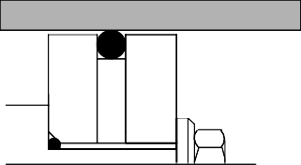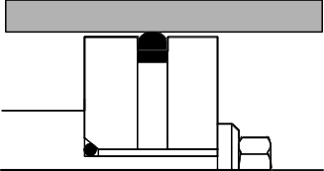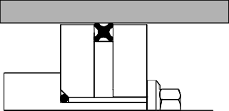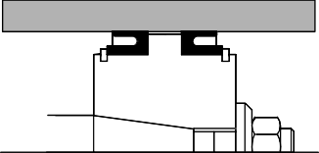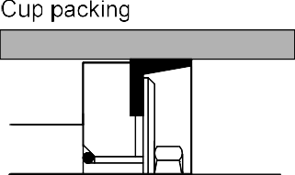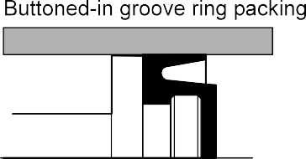*Cylinder seals*

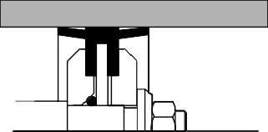 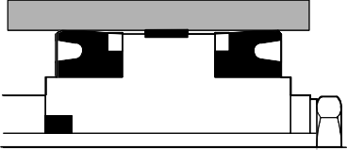



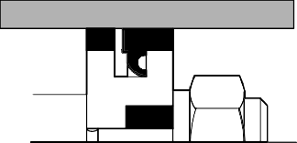

*TP101 • Festo Didactic*

# 169



*Chapter B-3*

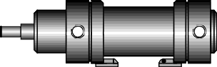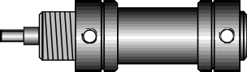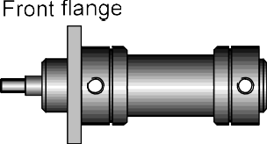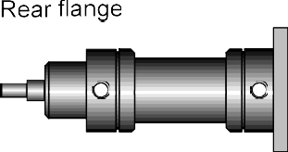The type of mounting is determined by the manner in which the cylinder is to be fitted to a machine or fixture. The cylinder can be designed with a permanent type of mounting if it does not have to be altered at any time. Alternatively, the cylinder can utilise adjustable types of mounting which can be altered at a later date by using suitable accessories on the modular construction principle. This results in considerable simplification in storage, especially where a large number of pneumatic cylinders are used as only the basic cylinder and optional mounting parts need to be stored.

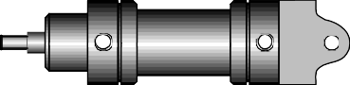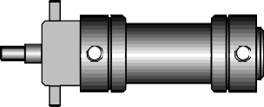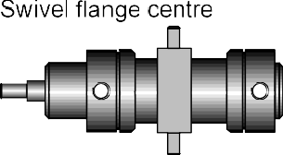The cylinder mounting and the piston rod coupling must be matched carefully to the relevant application since cylinders must be loaded only in the axial direction.

*Mounting*

*Fig. 3.16*

*Mounting arrangements for cylinders*

*Festo Didactic • TP101*

# 170

*Chapter B-3*

As soon as force is transmitted to a machine, stresses occur at the cyl- inder. If shaft mismatching and misalignments are present, bearing stresses at the cylinder barrel and piston rod can also be expected. The consequences are :

• High edge pressures on the cylinder bearing bushes leading to in- creased wear

• High edge pressures on the piston rod guide bearings

• Increased and uneven stresses on piston rod seals and piston seals.

• With large cylinder strokes, the buckling load of the piston rod should be observed

* 1. Cylinder performance characteristics

Cylinder performance characteristics can be determined theoretically or by the use of manufacturer’s data. Both methods are acceptable, but in general the manufacturer's data is more relevant to a particular design and application.

*Piston force*

The piston force exerted by the cylinder is dependent upon the air pres- sure, the cylinder diameter and the frictional resistance of the sealing components. The theoretical piston force is calculated by the formula:

|  |  |  |
| --- | --- | --- |
| Fth | = | A • p |
| Fth | = | Theoretical piston Force (N) |
| A | = | 2  Useful piston Area (m ) |
| p | = | Operating Pressure (Pa) |

In practice, the effective piston force is significant. When calculating this, frictional resistance should be taken into consideration. Under normal operating conditions (pressure range of 400 to 800 kPa / 4 to 8 bar) fric- tional force of approx. 10% of the theoretical piston force can be as- sumed.

Single-acting cylinder

Feff = (A • p) - (FR + FF)

*TP101 • Festo Didactic*

# 171

*Chapter B-3*

Double-acting cylinders

|  |  |  |  |
| --- | --- | --- | --- |
| Forward stroke | Feff | = | (A • p) - FR |
| Return stroke | Feff Feff | =  = | (A' • p) - FR  effective piston force (N) |

A = useful piston surface (m )

2

D*2 • π*

= ( 4 )

A' = useful annular surface (m )

2

= (D

2

* d2 ) *π*

4

p = Working pressure (Pa)

FR = Frictional force (approx. 10 % of Fth) (N) FF = Return spring force (N)

D = Cylinder diameter (m)

d = Piston rod diameter (m).

*Fig. 3.17*



*Pressure vs. force diagram*



*Festo Didactic • TP101*

# 172

*Chapter B-3*

*Stroke length*

*Fig. 3.18*

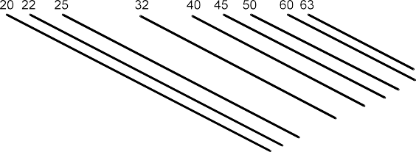

*Buckling diagram*

The stroke lengths of pneumatic cylinders should not be greater than 2 m and for rodless cylinders 10 m.

With excessive stroke lengths the mechanical stress on the piston rod and on the guide bearings would be too great. To avoid the danger of buckling, the buckling diagram should be observed with large stroke lengths.



*TP101 • Festo Didactic*

# 173

*Chapter B-3*

The piston speed of pneumatic cylinders is dependent on the load, the prevailing air pressure, the length of pipe, the cross-sectional area of the line between the control element and the working element and also the flow rate through the control element. In addition, the speed is influenced by the end position cushioning.

The average piston speed of standard cylinders is about 0.1-1.5 m/sec. With special cylinders (impact cylinders), speeds of up to 10 m/sec are attained. The piston speed can be regulated by one way flow control valves and speed increased by the use of quick exhaust valves.

*Piston speed*

*Fig. 3.19*

*Average piston speed*

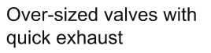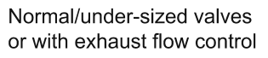







*Festo Didactic • TP101*

# 174

*Chapter B-3*

*Air consumption*

For the preparation of the air, and to obtain facts concerning power costs, it is important to know the air consumption of the system. The air consumption is specified in litres of air drawn in per minute. For a par- ticular operating pressure, piston diameter, stroke and stroke number, the air consumption is calculated by:

Air consumption =

Compression ratio • Piston surface • Stroke • Stroke number per minute

101.3 *+* Operating pressure (in kPa)

Compression ratio =

101.3

*Fig. 3.20*

*Air consumption chart*





The formulae for the calculation of air consumption in accordance with the air consumption diagram are as follows:

for single-acting cylinders qB = s • n • qH

for double-acting cylinders

|  |  |  |
| --- | --- | --- |
| qB | = | 2 • s • n • qH |
| qB | = | Air consumption (l/min) |
| s | = | Stroke (cm) |
| n | = | Number of strokes per minute (1/min) |
| qH | = | Air consumption per cm of stroke (l/cm) |

*TP101 • Festo Didactic*

# 175

*Chapter B-3*

With these formulae, the varying air consumption of double-acting cylin- ders during forward and return stroke are not taken into consideration. This can be disregarded due to the different tolerances in lines and valves.

The overall air consumption of a cylinder also includes the filling of dead zones. The air consumption required to fill dead zones can be up to 20% of the air consumption. Dead zones of a cylinder are compressed air supply lines in the cylinder itself and not zones in the end positions of the piston which are effective for the stroke.

|  |  |  |
| --- | --- | --- |
| *Piston diameter in mm* | *Cover side*  *3*  *in cm* | *Base side*  *3*  *in cm* |
| 12 | 1 | 0.5 |
| 16 | 1 | 1.2 |
| 25 | 5 | 6 |
| 35 | 10 | 13 |
| 50 | 16 | 19 |

*Festo Didactic • TP101*

*T 3.1*

*Dead zones of cylinders (1000 cm³ = 1l)*

|  |  |  |
| --- | --- | --- |
| *Piston diameter in mm* | *Cover side*  *3*  *in cm* | *Base side*  *3*  *in cm* |
| 70 | 27 | 31 |
| 100 | 80 | 88 |
| 140 | 128 | 150 |
| 200 | 425 | 448 |
| 250 | 2005 | 2337 |

# 176

*Chapter B-3*

3.6 Motors

Devices which transform pneumatic energy into mechanical rotary movement with the possibility of continuous motion are known as pneu- matic motors. The pneumatic motor with unlimited angle of rotation has become one of the most widely used working elements operating on compressed air. Pneumatic motors are categorised according to design:

* + Piston motors
  + Sliding-vane motors
  + Gear motors
  + Turbines (high flow)

*Fig. 3.21*

*Air motor*

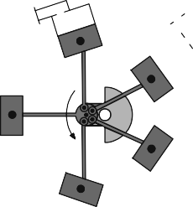

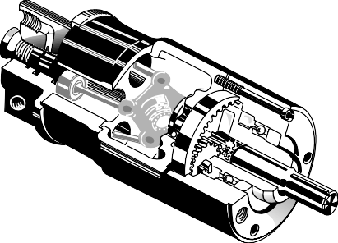

*Piston motors*

This type of design is further subdivided into radial and axial piston mo- tors. The crank shaft of the motor is driven by the compressed air via reciprocating pistons and connecting rods. To ensure smooth running several pistons are required. The power of the motor depends on input pressure, number of pistons, piston area, stroke and piston speed.

The working principle of the axial piston motor is similar to that of the radial piston motor. The force from 5 axially arranged cylinders is con- verted into a rotary motion via a swash plate. Compressed air is applied to two pistons simultaneously, the balanced torque providing smooth running of the motor.

These pneumatic motors are available in clockwise or anti-clockwise rotation. The maximum speed is around 5000 rpm, the power range at normal pressure being 1.5 - 19 kW (2 - 25 hp).

*TP101 • Festo Didactic*

# 177

*Chapter B-3*

Because of their simple construction and the low weight, sliding vane motors are used for hand tools.

An eccentric rotor is contained in bearings in a cylindrical chamber. Slots are arranged in the rotor. The vanes are guided in the slots of the rotor and forced outwards against the inner wall of the cylinder by centrifugal force. With other designs, the vanes are moved via springs. This en- sures that the individual chambers are sealed. The rotor speed is be- tween 3000 and 8500 rpm. Here too, clockwise or anti-clockwise units are available. Power range 0.1 - 17 kW (0.14 - 24 hp).

In this design, torque is generated by the pressure of the air against the teeth profiles of two meshed gear wheels. One of the gear wheels is secured to the motor shaft. Gear motors are produced with spur or heli- cal gearing. These gear motors are used in applications with a very high power rating ( up to 44 kW/60 hp). The direction of rotation is also re- versible for these motors.

Turbine motors can be used only where a low power is required. The speed range is very high. For example, the Dentists' air drill operates at 500,000 rpm. The working principle is the reverse of the flow compres- sor.

Characteristics of pneumatic motors are:

• Smooth regulation of speed and torque

• Small size (weight)

• Overload safe

• Insensitive to dust, water, heat, cold

• Explosion proof

• Large speed selection

• Maintenance minimal

• Direction of rotation easily reversed

*Sliding vane motors*

*Gear motors*

*Turbines (flow motors)*

*Festo Didactic • TP101*

# 178

*Chapter B-3*

3.7 Indicators

Optical indicators visually represent the operating status of the pneu- matic system and serve as diagnostic aids.

Some of the visual devices are:

• Counters, for displaying counting cycles

• Pressure gauges, to indicate air pressure values

• Timers, with visual indication of time delay

• Optical indicators

*Optical indicators*

*T 3.2*

*Optical indicators*

With the optical indicators the colour codes represent certain functions in the cycle. The visual indicators are mounted on the control panel to indi- cate status of control functions and the sequential steps currently active. The colours for visual indicators in accordance with VDE 0113 are:

|  |  |  |
| --- | --- | --- |
| *Colour* | *Meaning* | *Notes* |
| Red | Immediate danger, alarm | Machine status or situations requiring immediate intervention. |
| Yellow | Caution | Change or imminent change of condi- tions. |
| Green | Start, on | Normal operation, safe situation, free entry |
| Blue | Special information | Special meaning which cannot be made clear by red, yellow or green. |
| White or Clear | General information | Without special meaning. Can also be used in cases where there is doubt as to the suitability of the three colours red, yellow or green. |

*TP101 • Festo Didactic*

# 179

*Chapter B-4*

Chapter 4

Directional control valves

*Festo Didactic • TP101*

# 180

*Chapter B-4*

4.1 Configuration and construction

Directional control valves are devices which influence the path taken by an air stream. Normally this involves one or all of the following: opening the passage of air and directing it to particular air lines, cancelling air signals as required by blocking their passage and/or relieving the air to atmosphere via an exhaust port. The directional control valve is charac- terised by its number of controlled connections or ways, the number of switching positions and the method of actuation. However, these sym- bols do not provide any information about the constructional design, but merely indicate the function of the valve.

The normal position on valves with existing reset, e.g. spring, refers to the switching position assumed by the moving parts of the valve, if the valve is not connected.

The initial position is the switching position assumed by the moving parts of a valve after the valve has been installed in a system and the system pressure has been switched on and possibly also the electrical voltage, and with which the designated switching program starts.

The constructional principle of a directional control valve is an important factor as far as the service life, switching time, type of actuation, connec- tion methods and size are concerned.

Designs are categorised as follows:

• Poppet valves:

– Ball seat valve

– Disc seat valve

• Slide valves :

– Longitudinal slide valve (spool valve)

– Longitudinal flat slide valve

– Plate slide valve

*Poppet valves*

*Slide valves*

With poppet valves the connections are opened and closed by means of balls, discs, plates or cones. The valve seats are usually sealed simply using flexible seals. Seat valves have few parts which are subject to wear and hence they have a long service life. They are insensitive to dirt and are robust. The actuating force, however, is relatively high as it is necessary to overcome the force of the built-in reset spring and the air pressure.

In slide valves, the individual connections are linked together or closed by means of spools, flat slide or plate slide valves.

*TP101 • Festo Didactic*

# 181

*Chapter B-4*

* 1. 2/2-way valve

The 2/2-way valve has two ports and two positions (open, closed). It is rarely used except as an on-off valve, since its only function is to enable signal flow through and cannot release the air to atmosphere once in the closed position in contrast to the 3/2-way vlave. The 2/2-way valve is normally of the ball seat construction.

This valve can be operated either manually, mechanically or pneumati- cally.

* 1. 3/2-way valve

The 3/2-way valve is a signal generating valve, with the characteristic that a signal on the output side of the valve can be generated and also cancelled. The 3/2-way valve has three ports and two positions. The addition of the exhaust port 3 enables the signal generated via the pas- sage through the 3/2-way valve to be cancelled. The valve connects the output signal 2 to exhaust 3 and thus to atmosphere in the initial posi- tion. A spring forces a ball against the valve seat preventing the com- pressed air from flowing from the air connection 1 to the working line 2.

*Fig. 4.1*

*3/2-way valve, normally closed, ball seat*

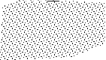

*Festo Didactic • TP101*

# 182

*Chapter B-4*

Actuation of the valve plunger causes the ball to be forced away from the seat. In doing this, the opposing force of the reset spring and that generated from the compressed air must be overcome.

In the actuated state, connection 1 and 2 are connected and the valve is switched to flow. The vlav is actuated either manually or mechanically. The actuation force required is dependent on the supply pressure, spring force and the friction in the valve. The actuation force limits the feasible size of the valve. The construction of the ball seat valve is very simple and compact.

*Fig. 4.2*

*Circuit diagram: controlling a single- acting cylinder*



In this circuit the 3/2-way valve 1S controls a single-acting cylinder 1A. The push button activated valve is at rest with the 1 port blocked and the cylinder exhausted to atmosphere via 2 to 3. The operation of the push button diverts the 1 supply to the 2 port and the cylinder extends against spring force. When the push button is released, the valve returns by spring, and the cylinder is returned to its initial position by the cylinder return spring.

*TP101 • Festo Didactic*

# 183

*Chapter B-4*

*Fig. 4.3*

*3/2-way valve:*

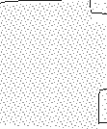

*disc seat normally closed, unactuated*

The valve shown here is constructed on the disc seat principle. The sealing is simple but effective. The response time is short and a small movement results in a large cross-sectional area being available for air flow. Like the ball seat valves, they are insensitive to dirt and thus have a long service life. The 3/2-way valves are used for controls employing single-acting cylinders or for generating signals supplied to control ele- ments.

*Fig. 4.4*

*3/2-way valve:*



*disc seat normally closed, actuated*

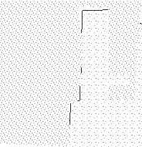

*Festo Didactic • TP101*

# 184

*Chapter B-4*

A 3/2-way valve in which the normal position is open to flow from 1 to 2, is referred to as a normally open valve. Initially the 1 port is connected to the 2 port through the stem of the valve and the valve disc seat is closed at the 3 port. When the plunger is operated, the 1 air is initially blocked by the stem seat and then the disc is pushed off its seat to exhaust the output air to atmosphere via the passage 2 to 3. When the plunger is released, the piston with the two sealing seats is returned to the initial position by the return spring. Once again the 3 port is blocked and air is supplied from 1 to 2.

The valves can be actuated manually, mechanically, electrically or pneumatically. Different actuation methods can be applied to suit the application.

*Fig. 4.5*

*3/2-way valve: disc seat normally open,*



*unactuated*

*TP101 • Festo Didactic*

# 185

*Chapter B-4*

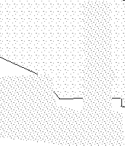

In this circuit diagram, pressure is applied to the single-acting cylinder via the 3/2-way valve in normally open position 1V. The cylinder piston has advanced into the initial position. If the valve is actuated, the air supply from 1 to 2 is shut off. The piston chamber is exhausted via port 2 to 3, and the piston rod retracts due to the force of the return spring.

*Fig. 4.6*

*3/2-way valve:*

*disc seat normally open, actuated*

*Fig. 4.7*

*Circuit diagram: controlling a single- acting cylinder*

*Festo Didactic • TP101*

# 186

*Chapter B-4*

*3/2-way hand slide valve*

*Fig. 4.8*

*3/2-way hand slide valve*

The construction of the valve is simple. Actuation is effected by displac- ing the grip sleeve lengthwise. This valve is used as a shut-off valve, primarily for the pressurising and exhausting of control systems or sys- tem components.

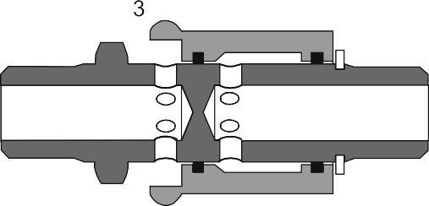

*TP101 • Festo Didactic*

# 187

*Chapter B-4*

The pneumatically actuated 3/2-way valve is operated by an air signal at

12. The circuit diagram shown illustrates a pneumatically actuated valve with spring return in normally closed position.

*Pneumatically actuated:*

*3/2-way valve*

*Fig. 4.9*

*3/2-way valve single pilot, normally closed, with spring return, unactuated*

Air applied at the 12 port moves the valve plunger against the reset spring. The connections 1 and 2 are connected. Upon release of the signal at port 12, the pilot spool is returned to the initial position by the return spring. The disc closes the connection between 1 and 2. The ex- cess air in the working line 2 is exhausted through 3. The single pilot 3/2-way valve with return spring can be configured as normally closed or as normally open.

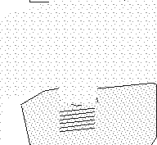

*Festo Didactic • TP101*

# 188

*Chapter B-4*

*Fig. 4.10*

*3/2-way valve single pilot, normally closed, with spring*

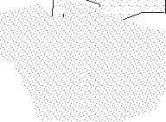

*return, actuated*

*Fig. 4.11*



*Circuit diagram: controlling a single- acting cylinder*



*TP101 • Festo Didactic*

# 189

*Chapter B-4*

The pneumatically actuated valve can be used as a control element, when used in an indirect control. The signal for extension of the cylinder 1A is initiated indirectly by a push button 3/2-way valve 1S which sup- plies the control signal to the control element 1V.

For the normally open position, ports 1 and 3 only need to be inversely connected to the normally closed position. The head of the valve with port 12 can be rotated 180°. The designation of the pilot port then is 10.

*Fig. 4.12*

*3/2-way valve, single pilot, normally open, unactuated*

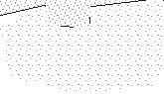

If a normally open valve is used at the position of valve 1V, then the cyl- inder is initially extended and upon operation of the push button of valve 1S, the cylinder retracts.







*Festo Didactic • TP101*

*Fig. 4.13*

*Circuit diagram: controlling a single- acting cylinder, indirect*

# 190

*Chapter B-4*

*Servo controlled: 3/2- way roller lever valve*

*Fig. 4.14*

*Pilot valve: left unactuated, right actuated*

Piloted valves require only minimal actuating forces. A small hole con- nects the pressure connection 1 and the pilot valve. If the roller lever is operated, the pilot valve opens. Compressed air flows to the diaphragm and actuates the main valve disc. The first effect is the closing of the path 2 to 3 followed by the second disc seat opening the airway from 1 to 2.

The return position is effected by means of releasing the roller lever, thereby closing the pilot valve. The valve is exhausted via the hollow stem. The pilot piston of the main valve is returned to its initial position via the reset spring.

This type of valve can be used as either a normally closed valve or nor- mally open valve by changing ports 1 and 3 and by rotating the head 180°.



*TP101 • Festo Didactic*

# 191

*Chapter B-4*

*b*

*Fig. 4.15*

*3/2-way roller lever*

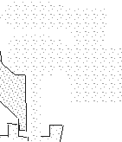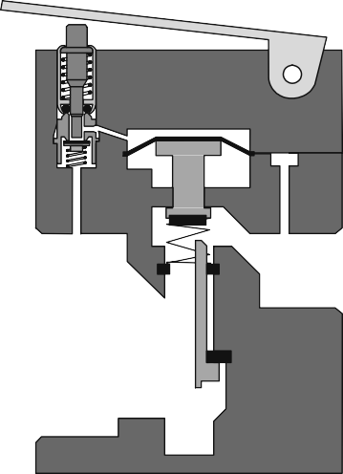

*valve, internal pilot, normally closed*



*Fig. 4.16*

*3/2-way roller lever*

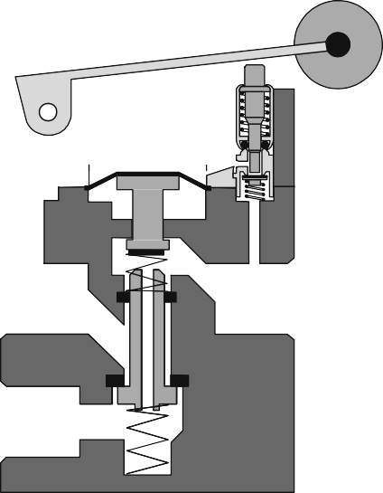

*valve, internal pilot, normally open*



*Festo Didactic • TP101*

# 192

*Chapter B-4*

*Roller lever valve with idle return*

*Fig. 4.17*

*Roller lever valve with idle return*

The roller lever valve with idle return only switches if the movement of the trip cam on the roller lever is in a certain direction. The valve is used as a limit switch for the position sensing of the extended and retracted piston rod. Care should be taken to ensure that the valve is fitted in the correct direction of movement.

Likewise, this type of valve can be used either in the normally open or normally closed position. In the case of the normally open position, only ports 1 and 3 need to be inversely connected to the nomally closed posi- tion. The head of the valve with roller lever actuator can be repositioned by 180o.

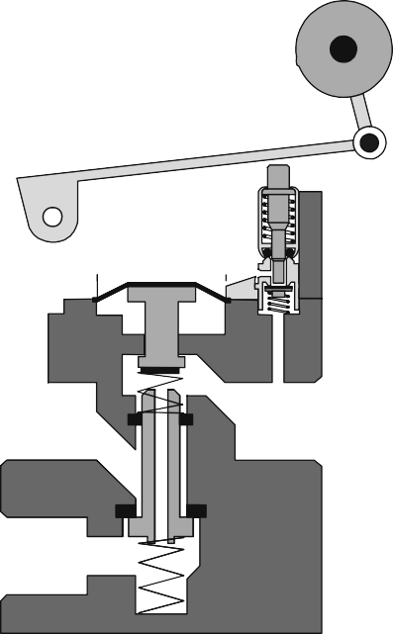

*TP101 • Festo Didactic*

# 193



*Chapter B-4*

4.4 4/2-way valve

The 4/2-way valve has four ports and two positions.

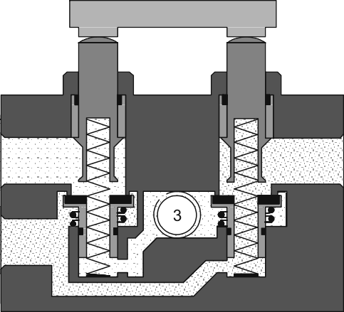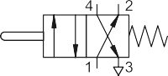

A disc-seat 4/2-way valve is similar in construction to the combination of two 3/2-way valves, one valve normally closed and the other normally open.

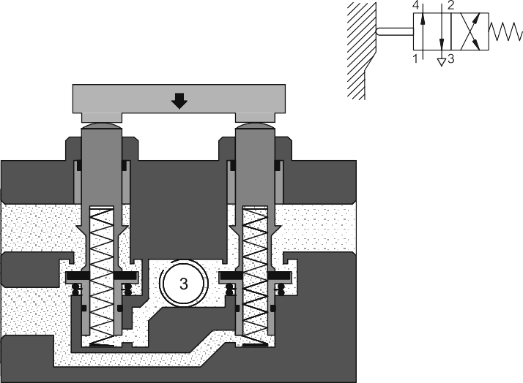

*Festo Didactic • TP101*

*Fig. 4.18*

*4/2-way valve,*

*disc seat, unactuated*

*Fig. 4.19*

*4/2-way valve, disc seat, actuated*

# 194

*Chapter B-4*

Actuation of the valve: When the two plungers are actuated simultane- ously, 1 to 2 and 4 to 3 are closed by the first movement. By pressing the valve plungers further against the discs, opposing the reset spring force, the passages between 1 to 4 and from 2 to 3 are opened.

The valve has a non-overlapping exhaust connection and is returned to its start position by the spring. The valves are used for controls employ- ing double-acting cylinders.

There are other actuating methods and types of construction available for the 4/2-way valve including push button, single air pilot, double air pilot, roller lever actuated, spool and sliding plate. In the main, the 4/2- way valve is utilised in similar roles as the 5/2-way valve.

*Fig. 4.20*



*Circuit diagram: controlling a double- acting cylinder, direct*

The longitudinal flat slide valve has a control piston for the reversal of the valve. However, the lines are interconnected or separated from one another by means of an additional flat slide.

*TP101 • Festo Didactic*

# 195

*Chapter B-4*

*Fig. 4.21*

*4/2-way double pilot valve, longitudinal flat slide*



The valve is reversed by means of direct pneumatic actuation. When the compressed air is removed from the control port, the control piston re- mains in the respective position until it receives a signal from the oppo- site control port.

4.5 4/3-way valve

The 4/3-way valve has four ports and three positions. An example of the 4/3 way valve is the plate slide valve with hand or foot actuation. By turn- ing two discs, channels are connected with one another.

*Fig. 4.22*

*4/3-way plate slide valve, mid-position closed*



*Festo Didactic • TP101*

# 196

*Chapter B-4*

*Fig. 4.23*



*4/3-way plate slide valve,*

*cross section*

In this circuit diagram the lines of the 4/3-way valve are closed in the middle position. This enables the piston rod of a cylinder to be stopped in any position over its stroke range, although intermediate positions of the piston rod cannot be located with accuracy. Owing to the compressi- bility of air, another position will be assumed if the load on the piston rod changes.

*Fig. 4.24*



*Circuit diagram: controlling a double- acting cylinder, direct*

*TP101 • Festo Didactic*

# 197

*Chapter B-4*

4.6 5/2-way valve

The 5/2-way valve has five ports and two positions. The 5/2-way valve is used primarily as a control element for the control of cylinders.

An example of the 5/2-way valve, the longitudinal slide valve, uses a pilot spool as a control component. This connects or separates the cor- responding lines by means of longitudinal movements. The required actuating force is lower because there are no opposing forces due to compressed air or spring.

All forms of actuation can be used with longitudinal slide valves, i.e. manual, mechanical, electrical or pneumatic. These types of actuation can also be used for resetting the valve to its starting position.

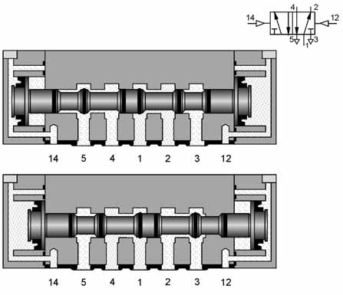

*Festo Didactic • TP101*

*Fig. 4.25*

*5/2-way valve: longitudinal slide principle*

# 198

*Chapter B-4*

The actuation travel is considerably larger than with seat valves. Sealing presents a problem in this type of slide valve. The type of fit known in hydraulics as metal to metal, requires the spool to fit precisely in the bore of the housing.

In pneumatic valves, the gap between spool and housing bore should not exceed 0.002 - 0.004 mm, as otherwise the leakage losses will be too great. To save these expensive fitting costs, the spool is often sealed with 0-rings or double-cup packings or the bore of the housing is sealed with 0-rings. To avoid damaging the seals, the connecting ports can be distributed around the circumference of the spool housing.

*Fig. 4.26*



*Circuit diagram: controlling a double- acting cylinder, indirect*



In general the 4/2-way valve is replaced by the 5/2-way valve. The 5/2- way valve has advantages in passage construction and allows the ex- haust of both extension and retraction air for cylinders to be separately controlled. The 5/2-way valve circuit carries out the same primary control functions as the 4/2-way valve circuit.

*TP101 • Festo Didactic*

# 199

*Chapter B-4*

Another method of sealing is to use a suspended disc seat with relatively small switching movement. The disc seat seal connects the 1 port to either the 2 port or the 4 port. The secondary seals on the spool pistons close whichever exhaust port is not required. The valve in the diagram below has a manual override button at each end to manually operate the valve spool.

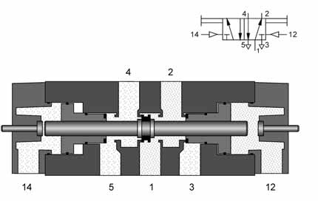

The 5/2-way double pilot valve has the characteristic of memory control. The valve is reversed from port 14 or 12 by means of reciprocal pneu- matic signals. This new position is memorised until another unique sig- nal occurs.

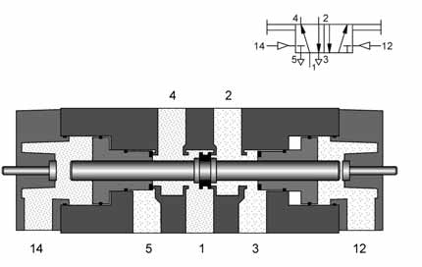

*Festo Didactic • TP101*

*Fig. 4.27*

*5/2-way double pilot valve, suspended disc seat,*

*flow from 1 to 2*

*Fig. 4.28*

*5/2-way double pilot valve, suspended disc seat,*

*flow from 1 to 4*

# 200

*Chapter B-4*

4.7 5/3-way valve

The 5/3-way valve has five working ports and three switching positions. With these valves, double-acting cylinders can be stopped within the stroke range. This means a cylinder piston under pressure in mid- position is briefly clamped in the normally closed position and in the normally open position, the piston can be moved unpressurised. If no signals are applied at either of the two control ports, the valve remains spring-centred in mid position.

*Fig. 4.29*

*5/3-way valve, normally closed*

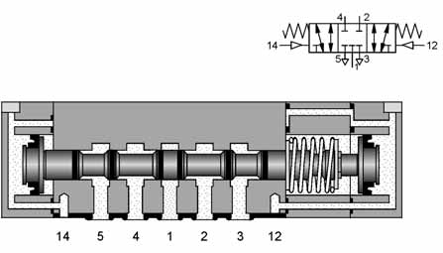

*TP101 • Festo Didactic*

# 201

*Chapter B-4*

4.8 Flow values of valves

Pressure loss and air flow rate are important functions for the user. The selection of a valve is dependent on

• Volume and speed of cylinder

• Required switching frequency

• Permissible pressure drop

Pneumatic valves are designated with their nominal flow rate. Various factors need to be taken into account to calculate flow values. The fac- tors are:

p1 Pressure at the valve input side (kPa or bar) p2 Pressure at the valve output side (kPa or bar)

*∆*p Differential pressure (p1 – p2) (kPa or bar) T1 Temperature (K)

qn Nominal flow rate (l/min)

During the measurement, air is to flow through the valve in one direction. The input pressure and output pressure are measured and the air flow is measured by means of a flow meter.

Data regarding the nominal flow values can be found in the manufac- turer’s catalogue.

*Festo Didactic • TP101*

# 202

*Chapter B-4*

4.9 Reliable operation of valves

Mounting of roller lever valves:

The reliability of a control sequence is heavily dependent upon the cor- rect fitting of the limit valves. For all designs of limit valves the mounting must allow simple adjustment or readjustment of the limit valve position in order to achieve precise co-ordination of the cylinder motions within a control sequence.

Fitting of valves:

Apart from a careful selection of valves, correct fitting is a further pre- requisite for reliable switching characteristics, trouble-free operation and easy access for repair and maintenance work. This applies both to valves in the power section and valves in the control section.

Maintenance and repairs are facilitated by:

• Numbering of components

• Incorporation of visual displays

• Comprehensive documentation

Manually-actuated valves for signal input are generally fitted on a control panel or control desk. It is therefore practical and convenient to use valves with actuators that can be fitted onto the basic valve. Various actuators are available for a wide variety of input functions.

Valves in the form of control elements control the sequence of pneu- matic power components. They need to be constructed in such a way as to trigger as fast a reaction of the actuators as possible. The power valve should therefore be positioned as closely as possible to the actuator in order to keep line lengths, and thus switching times, as short as possi- ble. Ideally, the power valve should be fitted directly to the drive. An ad- ditional advantage of this is that connectors, tubing and assembly time can be saved.

*TP101 • Festo Didactic*

# 203

*Chapter B-5*

Chapter 5

Non-return, flow and pressure valves, valve combinations

*Festo Didactic • TP101*

# 204

*Chapter B-5*

5.1 Non-return valves

Non-return valves are devices which preferentially stop the flow in one direction and permit flow in the opposite direction. The pressure on the downstream side acts against the restrictive component, thereby assist- ing the sealing effect of the valve.

*Check valves*

*Fig. 5.1*

*Non-return valve*

*Junction elements*

Check valves can stop the flow completely in one direction. In the oppo- site direction the flow is free with a minimal pressure drop due to the resistance of the valve. Blocking of the one direction can be effected by cones, balls, plates or diaphragms.

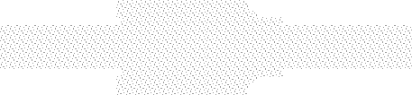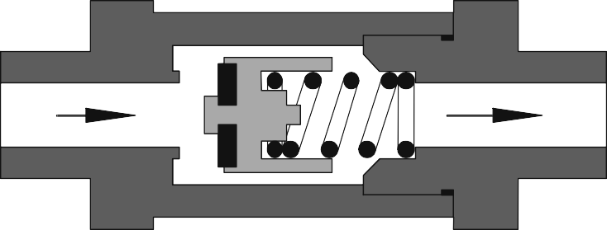

Elements fitted at a three way junction which have non-return character- istics and direct the movement of signal air. The two valves here referred to as junction elements have logic characteristics which determine the passage of two input signals. The dual pressure valve requires two sig- nals (AND function) to produce an output and the shuttle valve requires at least one signal input (OR function) to produce an output. These are processing elements whereby two signals are processed internally and the resulting signal is output at port 2.

*TP101 • Festo Didactic*

# 205

*Chapter B-5*

The dual pressure valve has two inlets 1 and 1(3) and one outlet A. Compressed air flows through the valve only if signals are applied to both inlets. One input signal at 1 or 1(3) blocks the flow due to the differ- ential forces at the piston slide. If signals are applied to both 1 and 1(3), the signal which is last applied passes to the outlet. If the input signals are of different pressures, the larger of the two pressures closes the valve and the smaller air pressure is transferred to the outlet 2. The dual pressure valve is used mainly for interlocking controls, safety controls, check functions and logic AND operations.

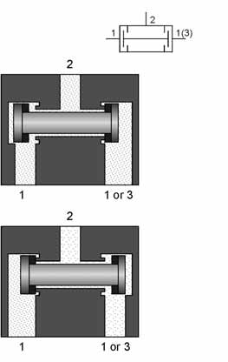

*Festo Didactic • TP101*

*Dual pressure valve: logic AND function*

*Fig. 5.2*

*Dual pressure valve: logic AND function*

# 206

*Chapter B-5*

*Fig. 5.3*

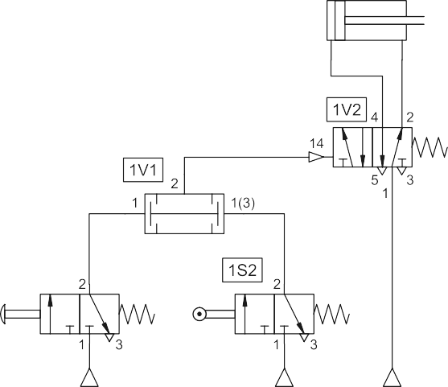

*Circuit diagram with dual pressure valve*

The dual pressure valve circuit is equivalent to the two input signalling devices in series, i.e. one after the other (3/2-way valve, normally closed position). The signal output is passed all the way through only if both signal elements are operated.

*Fig. 5.4*



*Circuit diagram: series AND function*



*TP101 • Festo Didactic*

# 207

*Chapter B-5*

A disadvantage of the switching variant is that in practice this often leads to extremely long lines between the valves. Moreover, the signal from valve 1S2 cannot be used in another logic, since the valve 1S2 is only pressurised if valve 1S1 is actuated.

This non-return element has two inlets 1 and 1(3) and one outlet 2. If compressed air is applied to the first inlet 1, the valve seat seals the op- posing inlet 1(3), the air flows from 1 to 2. Inlet 1 is closed, if air passes from 1(3) to 2. A signal is generated at the outlet. When the air flow is reversed, i.e. a cylinder or valve is exhausted, the seat remains in its previously assumed position because of the pressure conditions.

This valve is also called an OR element. If a cylinder or control valve is to be actuated from two or more positions, one or more shuttle valves should be used.



*Shuttle valve: logic OR function*

*Fig. 5.5*

*Shuttle valve: logic OR function*



*Festo Didactic • TP101*

# 208

*Chapter B-5*

In the example shown, a cylinder is to be advanced using two hand op- erated valves, which can be fitted at different distances from the cylin- der. Without the use of the shuttle valve, the compressed air would mainly flow via port 3 of the valve 1S2, if the valve 1S1 is actuated.

*Fig. 5.6*

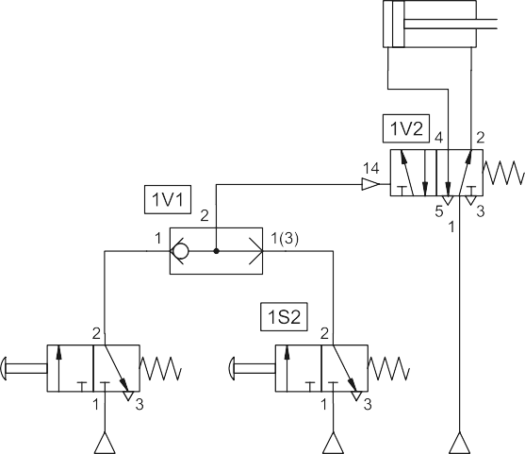

*Controlling a cylinder with two input elements*

Shuttle valves can be linked to create additional logic OR conditions e.g. as shown below: if any of three push buttons are operated, the cylinder is to extend.

*Fig. 5.7*

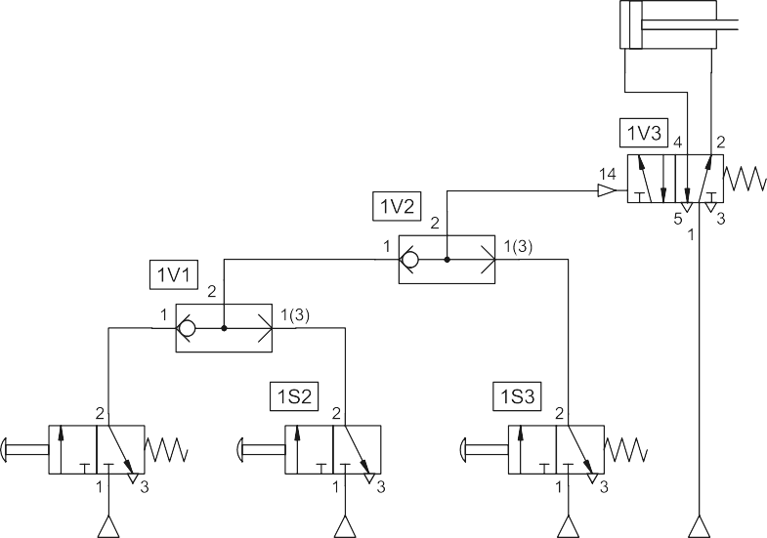

*Controlling a cylinder with three input elements*

*TP101 • Festo Didactic*

# 209

*Chapter B-5*

Quick-exhaust valves are used to increase the piston speed of cylinders. This enables lengthy return times to be avoided, particularly with single- acting cylinders. The principle of operation is to allow the cylinder to re- tract at its near maximum speed by reducing the resistance to flow of the exhausting air during motion of the cylinder. To reduce resistance, the air is expelled to atmosphere close to the cylinder via a large orifice opening. The valve has a closable supply connection 1, a closable ex- haust 3 and an outlet 2.

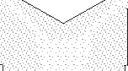

*Quick exhaust valve*

*Fig. 5.8*

*Quick exhaust valve: flow from 1 to 2*

*Festo Didactic • TP101*

# 210

*Chapter B-5*

If pressure is applied at port 1, then the sealing disc covers the exhaust 3, whereby the compressed air passes from 1 to 2. If pressure is no longer applied at 1, then the air from 2, moves the sealing disc against port 1 and closes this, whereby the exhaust air immediately vents to atmosphere. There is no need for the air to pass through a long and possibly restricted path to the directional control valve via the connecting lines. It is advantageous to mount the quick-exhaust valve directly on the cylinder or as near to it as possible.

*Fig. 5.9*

*Quick exhaust valve: exhaust from 2 to 3*



*Fig 5.10*



*Circuit diagram with quick exhaust valve*



*TP101 • Festo Didactic*

# 211

*Chapter B-5*

Shut-off valves are non-adjustable valves, which release or shut off flow in both directions. Typical examples are the stop cock and ball cock.



*Shut-off valves*

*Fig. 5.11*

*Stop cock*

5.2 Flow control valves

Flow control valves influence the volumetric flow of the compressed air in both directions. The throttle valve is a flow control valve.

Throttle valves are normally adjustable and the setting can be locked in position. Throttle valves are used for speed control of cylinders. Care must be taken that the throttle valve does not close fully, cutting off air from the system.



*Throttle valve, bi-directional*

*Fig. 5.12*

*Throttle valve*

*Festo Didactic • TP101*

# 212

*Chapter B-5*

Characteristics of flow control valves according to construction principle:

• Throttle valve:

In the throttle valve, the length of the throttling section is greater than

its diameter.

• Diaphragm valve:

In the diaphragm valve, the length of the throttling section is less

than its diameter.

*One-way flow control valve*

*Fig. 5.13*

*One-way flow control valve*

In the case of the one-way flow control valve, the air flow is throttled in one direction only. A check valve blocks the flow of air in the bypass leg and the air can flow only through the regulated cross-section. In the op- posite direction, the air can flow freely through the opened check valve. These valves are used for speed regulation of actuators and if possible, should be mounted directly on the cylinder.



 

*TP101 • Festo Didactic*

# 213

*Chapter B-5*

Fundamentally, there are two types of throttling circuits for double-acting cylinders:

• Supply air throttling

• Exhaust air throttling

For supply air throttling, one-way flow control valves are installed so that the air entering the cylinder is throttled. The exhaust air can escape freely through the check valve of the throttle valve on the outlet side of the cylinder. The slightest fluctuations in the load on the piston rod, such as occur for example when passing a limit switch, lead to very large ir- regularities in the feed speed.

A load in the direction of movement of the cylinder accelerates the cylin- der beyond the set value. Therefore supply air throttling can be used for single-acting and small volume cylinders.



*Supply air throttling*

*Fig. 5.14*

*Supply air throttling*



*Festo Didactic • TP101*

# 214

*Chapter B-5*

*Exhaust air throttling*

*Fig. 5.15*

*Exhaust air throttling*

With exhaust air throttling, the supply air flows freely to the cylinder and the exhaust air is throttled. In this case, the piston is loaded between two cushions of air. The first cushion effect is the supply pressure to the cyl- inder and the second cushion is the exhausting air being restricted at the one-way flow control valve orifice. Arranging throttle relief valves in this way contributes substantially to the improvement of feed behaviour. Ex- haust air throttling should be used for double-acting cylinders. In the case of miniature cylinders, supply and exhaust air flow control is to be selected because of the reduced air quantity.



*TP101 • Festo Didactic*

# 215

*Chapter B-5*

With mechanically adjustable one-way flow control valves, the speed of the cylinder can be changed during the stroke. The basic speed can be set via an adjusting screw. By means of an irregular shaped follower, which actuates the roller lever of the mechanically adjustable one-way flow control valve, the throttle cross section is correspondingly changed.

*Mechanically adjustable one-way flow control valve*

*Fig. 5.16*

*Mechanically adjustable one-way flow control valve*







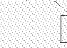

*Festo Didactic • TP101*

# 216



*Chapter B-5*

5.3 Pressure valves

Pressure control valves are elements which predominantly influence the pressure or are controlled by the magnitude of the pressure. They are divided into the three groups:

• Pressure regulating valve

• Pressure limiting valve

• Pressure sequence valve

*Pressure regulating*

*valve*

*Fig. 5.17*

*Pressure regulating valve*

*Pressure limiting valve*

The pressure regulating valve is dealt with under the section B 2.6 “Ser- vice unit”. The role of this unit is to maintain constant pressure even with fluctuating supply. The input pressure must be greater than the required output pressure.

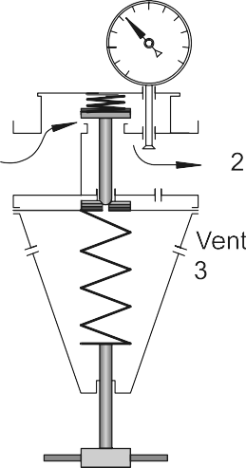The pressure limiting valves are used mainly as safety valves (pressure relief valves). They prevent the maximum permissible pressure in a sys- tem from being exceeded. If the maximum pressure has been reached at the valve inlet, the valve outlet is opened and the excess air pressure exhausts to atmosphere. The valve remains open until it is closed by the built-in spring after reaching the preset system pressure.

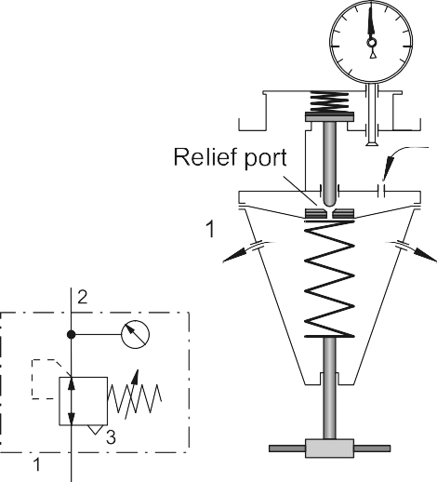

*TP101 • Festo Didactic*

# 217



*Chapter B-5*

The principle on which this valve acts is the same as for the pressure limiting valve. If the pressure exceeds that set on the spring, the valve opens.

The flow from 1 to 2 is closed. Outlet 2 is opened only if a preset pres- sure has built up in pilot line 12. A pilot spool opens the passage 1 to 2.

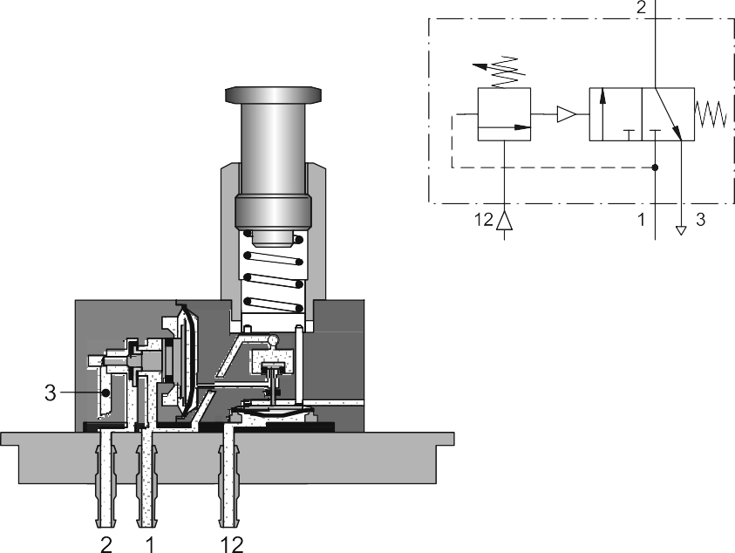

*Festo Didactic • TP101*

*Pressure sequence valve*

*Fig. 5.18*

*Adjustable pressure sequence valve*

# 218

*Chapter B-5*

Pressure sequence valves are installed in pneumatic controls where a specific pressure is required for a switching operation (pressure- dependent controls).

*Fig. 5.19*



*Circuit diagram with pressure sequence valve*



5.4 Combinational valves

Components of different control groups can be combined into the body of one unit with the features, characteristics and construction of a com- bination of valves. These are referred to as combinational valves and their symbols represent the various components that make up the com- bined unit. The following units can be defined as combinational valves:

• Time delay valves: for the delay of signals

• Air control blocks: for the execution of individual and oscillating movements using double-acting cylinders

• 5/4-way valve: for the stopping of double-acting cylinders in any position

• Air operated 8-way valve: for the control of feed units

• Pulse generator: for the execution of rapid cylinder movements

• Vacuum generator with ejector: for pick and place applications

• Stepper modules: for sequential control tasks

• Command memory modules: for startup with signal input conditions

*TP101 • Festo Didactic*

# 219

*Chapter B-5*

The time delay valve is a combined 3/2-way valve, one way flow control valve and air reservoir. The 3/2-way valve can be a valve with normal position open or closed. The delay time is generally 0-30 seconds for both types of valves.

*Time delay valve*

*Fig. 5.20*

*Time delay valve: normally closed*



By using additional reservoirs, the time can be extended. An accurate switch-over time is assured, if the air is clean and the pressure relatively constant.

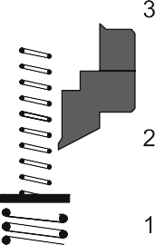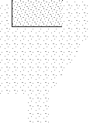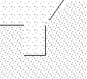

*Festo Didactic • TP101*

# 220



*Chapter B-5*

*Operational principle*

*Fig. 5.21*

*Time delay valve: normally open*

The following operational principle applies for a time delay valve with a 3/2-way valve in normally closed position: The compressed air is sup- plied to the valve at connection 1. The control air flows into the valve at 12 through a one-way flow control valve and depending on the setting of the throttling screw, a greater or lesser amount of air flows per unit of time into the air reservoir. When the necessary control pressure has built up in the air reservoir, the pilot spool of the 3/2-way valve is moved downwards. This blocks the passage from 2 to 3. The valve disc is lifted from its seat and thus air can flow from 1 to 2. The time required for pressure to build up in the air reservoir is equal to the control time delay of the valve.

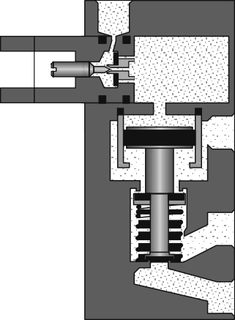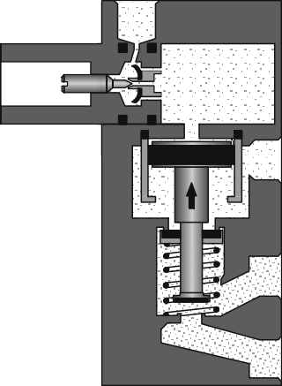If the time delay valve is to switch to its initial position, the pilot line 12 must be exhausted. The air flows from the air reservoir to atmosphere through the bypass of the one-way flow control valve and then to the exhaust line. The valve spring returns the pilot spool and the valve disc seat to their initial positions. Working line 2 exhausts to 3 and 1 is blocked.

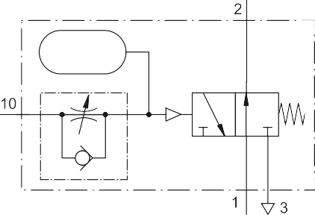

*TP101 • Festo Didactic*

# 221

*Chapter B-5*

The normally open time delay valve includes a 3/2-way valve which is open. Initially the output 2 is active. When the valve is switched by 10 the output 2 is exhausted to 3 and 1 is closed. The result is that the out- put signal is turned off after a set time delay.

The time delay corresponds to the pressure build up in the reservoir again. If the air at port 10 is removed, then the 3/2-way valve assumes the normal position.

The circuit below utilises two time delay valves, one a normally closed valve (1V2) and the other a normally open valve (1V1). Upon operation of the start button 1S1, the signal generated passes through the valve 1V1 and initiates the movement of cylinder extension (1A) via the 14 port of the control element 1V3. The time delay valve 1V1 has a short time delay set of 0.5 seconds. This is long enough to initiate the start signal but then the 14 signal is cancelled by the 10 pilot signal of the time delay valve. The cylinder operates limit valve 1S2. The time delay valve 1V2 receives a pilot signal which after the preset time opens the valve. This supplies the 12 signal which reverses the valve and retracts the cylinder. A new cycle can only be started via the start button and renewed actua- tion of the valve 1S1.

*Fig. 5.22*



*Circuit diagram with time delay valve*





*Festo Didactic • TP101*

# 222

*Chapter B-5*

The following illustrations show the time behaviour of circuits with time delay valves.

*Fig. 5.23*



*Time response of circuits * *with time delay valves*















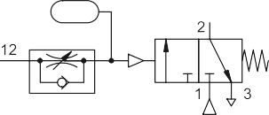

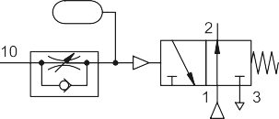

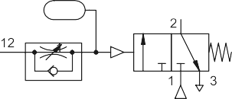

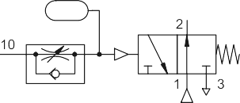

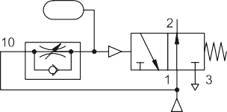

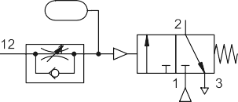

*TP101 • Festo Didactic*



# 223

*Chapter B-6*

Chapter 6 Systems

*Festo Didactic • TP101*

# 224

*Chapter B-6*

6.1 Selection and comparison of working and control media

To select the working and control media consideration must be given to the following:

• The work or output requirements

• The preferred control methods

• The resources and expertise available to support the project

• The systems currently installed which are to be integrated with the new project

Firstly, the individual advantages and disadvantages of the media avail- able must be considered, both as a control medium and as a working medium. Then the selections can be developed towards a solution.

*TP101 • Festo Didactic*

# 225

*Chapter B-6*

*T. 6.1*

*Working media*

|  |  |  |  |
| --- | --- | --- | --- |
| Criteria | Pneumatics | Hydraulics | Electrics |
| Force linear | Forces limited due to low pres- sure and the cylinder diameter, no energy consumption during stoppage | Large forces due to high pres- sure | Lower forces, poor efficiency, non overload-proof, high energy consumption during idling |
| Force, rotating | Full torque, even during stop- page, no energy consumption | Full torque, even during stop- page, but increased energy con- sumption | Minimal torque during stoppage |
| Movement, linear | Simple generation, high accel- eration, high speed | Simple generation, easily adjust- able | Complicated and expensive due to conversion by mechanical means or in the case of short distances via solenoids and for lower forces, linear motors |
| Movement, rotating  or swivel- ling | Compressed air motors with extremely high speeds, high operating costs, poor efficiency, swivel movement by means of conversion via gear rack and pinion | Hydraulic motors and swivel cylinders with lower speeds than pneumatic types, high efficiency | Greatest efficiency for rotary drives, limited speed |
| Adjust- ability | Easy adjustability of force via pressure and of speed via vol- ume, even in the lower speed range | Excellent adjustability of force and speed, can be accurately adjusted even in slow speed range | Limited possibility of use, whilst at the same time high cost |
| Energy storage and Transport | Large quantities possible, with- out expenditure, easily trans- portable in lines (approx. 1000 m) and compressed air bottles | Only limited storage possible using auxiliary medium of gas or by means of spring-loaded res- ervoir, transportable in lines of up to 100 m | Storage difficult and expensive (accumulator, battery) easily transportable over great dis- tances via lines |
| Environ- mental Effects | Resistant to temperature fluctua- tions, no explosion hazard, risk of icing in the event of high air humidity, high flow velocities and low ambient temperatures | Sensitive to temperature fluctua- tions, fire risk in the event of leakage and contamination | Resistant to temperature fluctua- tions, fire and explosion protec- tion are essential in hazardous areas |
| Energy costs | Too high compared to electricity, 1m³ compressed air at 600 kPa (6 bar) costs approx. DM 0.03 to 0.05, depending on system and degree of utilisation | Too high compared to electricity | Lowest energy costs |
| General | Components are overload-proof, exhaust air noise is unpleasant, silencing is therefore essential | Pump noise at higher pressures, components are overload-proof | Components are not overload- proof, or can only be protected against overload at high cost; noise during switching of contac- tors and solenoids |

*Festo Didactic • TP101*

# 226

*Chapter B-6*

*T. 6.2*

*Control media*

|  |  |  |  |  |
| --- | --- | --- | --- | --- |
| Criteria | Electrics | Electronics | Standard pressure pneumatics | Low-pressure pneumatics |
| Robustness of elements | Insensitive to envi- ronmental influences such as dust, humid- ity, etc. | Very sensitive to environmental influ- ences such as dust, humidity, interfer- ence fields, jolts and vibrations, long ser- vice life | Very insensitive to environmental influ- ences,  long service life if air is clean | Very insensitive to environmental influ- ences, sensitive to contaminated air, long service life |
| Switching time of elements | > 10 ms | << 1 ms | > 5 ms | > 1 ms |
| Signal speed | Light speed | Light speed | Approx. 10 - 40 m/s | Approx. 100 –200 m/s |
| Possible distances | Practically unlimited | Practically unlimited | Limited by signal speed | |
| Space requirements | Small | Very small | Small | Small |
| Main signal processing | Digital | Digital, analogue | Digital | Digital, analogue |

*TP101 • Festo Didactic*

# 227

*Chapter B-6*

* 1. Control theory

Differentiation between the control systems can be made according to the following viewpoints. The following illustrations respresent the control types according to DIN 19226. There are three main groups. The cate- gorisation of a control system to the three main groups depends on the problem definition. If it is a case of program control, the project designer has the choice of the three subgroups of program control .

*Fig. 6.1*



*Control types according to DIN 19226*

Pilot control system

There is always a clear relationship between the command or reference value and the output value provided disturbance variables do not cause any deviations. Pilot controls do not have a memory function.

Memory control system

When the command or reference value is removed or cancelled, in par- ticular after completion of the input signal, the output value achieved is retained (memorised). A different command value or an opposing input signal is required to return the output value to an initial value. Memory control systems always have a storage function.

*Control types according to DIN 19226*

*Festo Didactic • TP101*

# 228

*Chapter B-6*

Program control

The three types of program control are:

* + Step diagram control

In the case of step diagram control, the reference variables are sup-

plied by a program generator (program memory), whose output vari- ables depend on the path travelled or the position of a moving part of the controlled system.

* + Sequence control system

The sequence program is stored in a program generator which runs

through the program step-by-step according to the status attained by the system being controlled. This program may either be perma- nently installed or else read from punched cards, magnetic tapes or other suitable memories.

* + Time (schedule) control

In a time (schedule) control system, the command values are sup-

plied by a time-dependent program generator. Characteristics of a timing control system are, thus, the existence of a program generator and a time-dependent program sequence. Program generators may be :

* + - Cam shafts
    - Cams
    - Punched cards
    - Punched tape
    - Programs in an electronic memory

*Control system types*

Differentiation between the control systems can be made on the basis of different viewpoints. According to this standard, distinguishing features for control systems are in the form of the representation of information and in the form of signal processing.

*TP101 • Festo Didactic*

# 229

*Chapter B-6*

Analogue control system

A control system which operates predominantly with analogue signals within the signal processing section. Signal processing is effected pri- marily with continuously acting function elements.

Digital control system

A control system which operates chiefly using numerical digital signals within the signal processing section. The information is represented nu- merically. The function units are: Counters, registers, memories, arith- metic units.

Binary control system

A control system which operates predominantly with binary signals within the signal processing section and where the signals are not part of numerically represented data.

*Form of information representation*

*Fig. 6.2*



*Differentiation between the control systems: in the form of representation of information*



*Festo Didactic • TP101*

# 230

*Chapter B-6*

*Form of signal processing*

*Fig. 6.3*

*Differentiation between the control systems: in the form of signal processing*

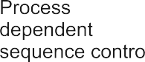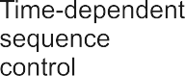

Synchronous control system

A control system where signal processing is synchronous to a clock pulse.

Asynchronous control system

A control system operating without clock pulses where signal modifica- tions are only triggered by a change in the input signals.

Logic control system

A control system where specific signal status for the output signals are assigned to the signal status of the input signals by means of Boolean logic connections (e.g. AND, OR, NOT).

*TP101 • Festo Didactic*

# 231

*Chapter B-6*

Sequence control system

A control system with compulsory stepped operation where switching on from one step to the next in the program is dependent upon certain con- ditions being satisfied. In particular, the programming of jumps, loops, branching, etc. is possible.

Sequence control is divided into two subgroups:

• Time-dependent sequence control system

A sequence control whose switching conditions are dependent only

on time. Step enabling conditions are generated via timers, or cam- shaft controllers with constant speed.

The existing term of timing control according to DIN 19226 is subject to the time-dependent specification of reference variables.

• Process-dependent

A sequence control system whose switching conditions are depend-

ent only on signals from the system being controlled. Step-diagram control as defined in DIN 19226 is a form of process-dependent se- quence control, whose step enabling conditions depend purely on the stroke-dependent signals of the controlled system.

* 1. Control system development

The development of the control system solution requires that the prob- lem is defined clearly. There are many ways of representing the problem in a descriptive or graphical form. The methods of representing the con- trol problem include:

• Positional sketch

• Displacement-step diagram

• Control chart

• Function diagram

• Function chart

• Circuit diagram

*Festo Didactic • TP101*

# 232

*Chapter B-6*

*Positional sketch*

*Fig. 6.4*

*Positional sketch example*

*Displacement-step*

*diagram*

*Note*

The positional sketch shows the relationship between the actuators and the machine fixture. The actuators are shown in the correct orientation. The positional sketch is not normally to scale and should not be too de- tailed. The diagram will be used in conjunction with the description of the machine operation and the motion diagrams.

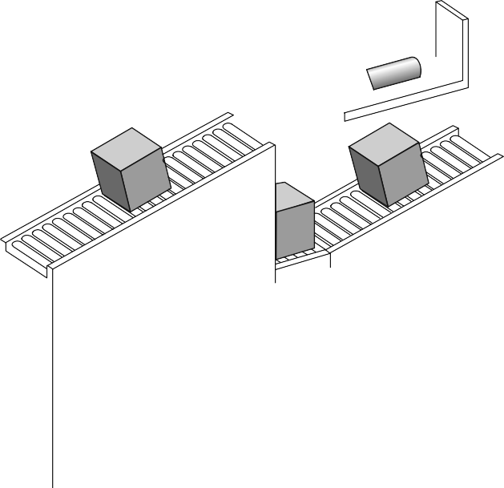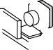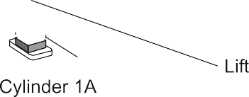

The displacement-step diagram and the displacement-time diagram are used for motion sequences. The displacement-step diagram represents the operating sequence of the actuators; the displacement is recorded in relation to the sequence step.

If a control system incorporates a number of actuators, they are shown in the same way and are drawn one below the other. Their interrelation can be seen by comparing the steps.

The VDI standard 3260 "Function diagrams of production machinery and installations" has been withdrawn. It is nonetheless used in this book to illustrate control sequences.

*TP101 • Festo Didactic*

# 233

*Chapter B-6*



In this case there are two cylinders 1A and 2A. In step 1 cylinder 1A ex- tends and then cylinder 2A extends in step 2. In step 3 cylinder 1A re- tracts and in step 4 cylinder 2A retracts. Step number 5 is equivalent to step 1.



In the case of a displacement-time diagram, the displacement is plotted in relation to the time.



*Festo Didactic • TP101*

*Fig. 6.5*

*Displacement-step diagram*

*Displacement-time diagram*

*Fig. 6.6*

*Displacement-time diagram*

# 234

*Chapter B-6*

*Control chart*

*Fig. 6.7*

*Control chart*

*Function diagram*

*Fig. 6.8*

*Function diagram*

In the control chart, the switching status of the control element is repre- sented in relation to the steps or the time. The switching time is not taken into account.

The control diagram in Fig. 6.7 shows the statuses of the control com- ponents (1V for cylinder 1A and 2V for cy1inder 2A) and the status of the limit switch 1S1 fitted at the front end position of the cylinder 1A.

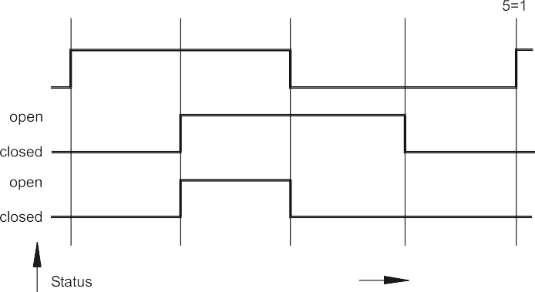

The function diagram is a combination of the motion diagram and the control chart. The lines representing the individual states are referred to as function lines













*TP101 • Festo Didactic*

# 235

*Chapter B-6*

Apart from the function lines, signal lines can also be entered in the function diagram.

The signal line output is at the signal element and the end at the point, where a change in status occurs, dependent on this signal. Arrows on the signal lines indicate the direction of signal flow.

*Fig. 6.9*



*Representation of signal lines*







Signal branchings are denoted by a dot at the point of branching. Sev- eral changes in status of components are introduced by a signal output.

In the case of the OR condition, a dot is placed at the point of conjunc- tion of the signal lines. Several signal outputs effect the same change in status irrespective of one another.

The AND condition is designated by means of an oblique stroke at the point of conjunction of the signal lines. A change in status only occurs, if all signal outputs are present.

*Festo Didactic • TP101*

# 236

*Chapter B-6*

*Fig. 6.10*



*Representation of input elements*

   

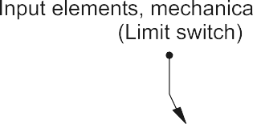

The designations of the individual input elements are entered at the out- put point of the respective signal line.

*Fig. 6.11*

*Displacement-step diagram*

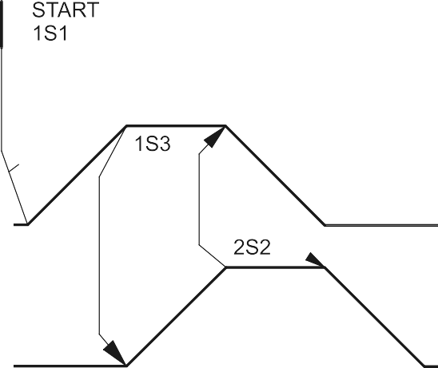

*with signal lines*





*TP101 • Festo Didactic*

# 237

*Chapter B-6*

The diagram illustrates the following sequence:

• If the limit switch 2S1 is actuated and the push button 1S1 is pressed by the operator, the piston rod of cylinder 1A extends.

• When the cylinder 1A reaches its forward end position, the limit switch 1S3 is actuated and the piston rod of cylinder 2A advances.

• When the cylinder 2A reaches its forward end position, the limit switch 2S2 is actuated and the piston rod of cylinder 1A retracts.

• When the cylinder 1A reaches its retracted end position, the limit switch 1S2 is actuated and the piston rod of cylinder 2A retracts.

• When cylinder 2A reaches its retracted end position, the limit switch 2S1 is actuated and the initial position is reached again.

Abbreviated notation is another possibility of representing motion se- quences. In this case, the cylinder designations 1A, 2A, etc. are used in the sequence. The signal for advancing is designated using a ‘+’ and the signal for retracting using a ‘-‘.

• The sequence 1A+ 2A+ 2A- 1A- is to be read as follows: Cylinder 1A advances, cylinder 2A advances, cylinder 2A retracts, cylinder 1A retracts. Sequential movements are written consecu-

tively.

• The sequence 1A+ 2A+ 2A-

1A- is to be read as:

Cylinder 1A advances, cylinder 2A advances and cylinder 1A re- tracts, cylinder 2A retracts. Simultaneous movements are written ver- tically.

*Abbreviated notation*

*Festo Didactic • TP101*

# 238

*Chapter B-6*

*Function chart*

*Fig. 6.12*

*Function chart: riveting process*

The function chart gives a clear picture of action, and reactions in se- quences. The diagram describes the following sequence:

* The clamp cylinder 1A is extended (1A+) and the limit valve then operated is 1S2.
* This limit 1S2 initiates the extension of cylinder 2A (2A+) which is the riveting process.
* The riveting cylinder fully extends and operates the limit 2S2. The limit 2S2 initiates the retraction of the riveting cylinder (2A-).
* The limit 2S1 is then operated which initiates the movement of cylin- der 1A unclamping and retracting (1A-).
* The full retraction of cylinder 1A is indicated by the limit 1S1 and this is the initial condition required for a new cycle to commence.

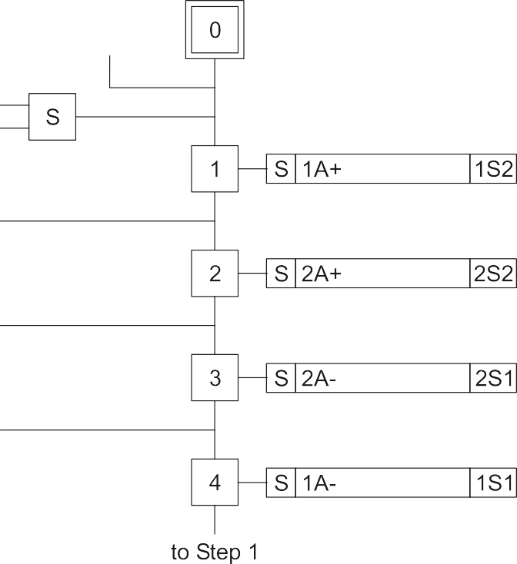





*TP101 • Festo Didactic*

# 239

*Chapter B-6*

The circuit diagram shows signal flow and the relationship between components and the air connections. There is no mechanical layout rep- resentation with the circuit diagram.

The circuit is drawn with the energy flow from the bottom to the top. The various levels of a circuit include the energy source, signal inputs, signal processing, control elements and the actuators. The position of the limit valves are marked at the actuator. Components and lines are identified by the component numbering system and the port (way) connection numbers. These allow cross reference to the components on the actual machine and make the circuit readable.

*Fig 6.13*

*Circuit diagram example*

*Circuit diagram*

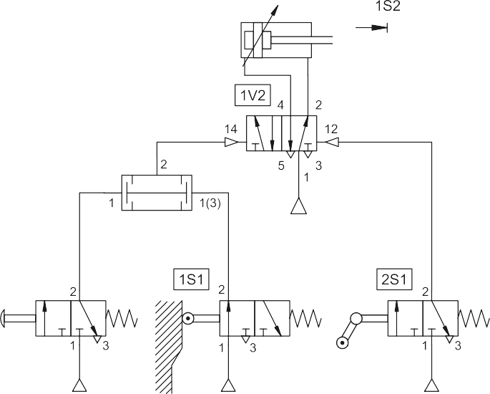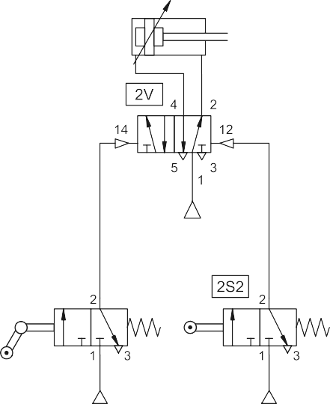

*Festo Didactic • TP101*

# 240

*Chapter B-6*

6.4 Development aspects

An important component in the transfer of power from the processor to the linear or rotary actuator is the directional control valve (DCV). The selection of the size and type of valve determines many of the operating characteristics of the actuator. The development in directional control valves is towards :

* + Sub-base and manifold mounting with common supply and exhaust
  + Directional control valves are optimised with respect to dead volume, actuating force and working loads. This results in fast switching of the valve.
  + The housing interior is specially designed to achieve a high flow rate.
  + Multiple function valves where characteristics are changed via wafer and seal variations
  + Multiple valves in single unit construction
  + Mounting of the DCV on the cylinder

The manifold mounted valves utilise a common supply port and exhaust ports. The exhausts can be tubed away separately or locally silenced as required. The compact and rigid mounting is suitable for a control cabi- net construction.

*Fig 6.14*

*Optimised individual valves and valve terminals*

* + 1. *Individual valve*
    2. *Valve terminal*
       1. b)

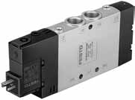 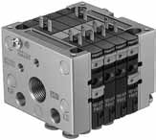

*TP101 • Festo Didactic*

# 241

*Chapter B-6*

6.5 Modern pneumatic drives

In addition to standard cylinders, which continue to be important as a low-cost, versatile drive component, special cylinders are also gaining importance. With these drives, additional components such as guides and retainers are frequently attached directly to the cylinder housing. This results in benefits such as a smaller fitting space and reduced wor- king loads. The reduced material, planning and assembly costs lead to a noticeable cost saving.

Multi-position cylinders are used for applications where more than two positions are to be approached. The following figure illustrates the mode of operation of a double-acting multi-position cylinder. One piston rod is attached to the frame, while the second is connected to the load. This type of cylinder can assume up to four different positions. In each case the cylinder is driven precisely against a stop.

Cylinder settings

Stroke 1

Stroke 2

Stroke 1 Stroke 2

*Multi-position cylinders*

*Fig. 6.15*

*Multi-position cylinders*

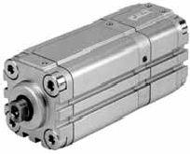

*Festo Didactic • TP101*

# 242

*Chapter B-6*

*Fluidic Muscle*

*Fig. 6.16*

*Application example with the Fluidic Muscle*

*Handling technology*

The Fluidic Muscle is a membrane contraction system. An impervious, flexible tube is covered with tightly woven threads in a diamond-shaped pattern. This creates a three-dimensional grid structure. The air flowing inwards deforms the grid structure. A tensile force is generated in the axial direction, which causes a contraction of the muscle in the event of increasing internal pressure.

In the extended state, the Fluidic Muscle generates up to ten times more force than a conventional pneumatic cylinder and uses only 40% of the energy while offering the same force. A third of the diameter is sufficient for the same force, while the stroke is shorter for the same overall length.

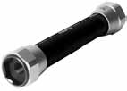

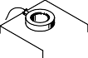

Handling and assembly operations frequently require components that can perform movements in two or three different directions. This sector was previously dominated by special designs. Today, standard handling modules that can be combined for specific applications are being used more and more.

*TP101 • Festo Didactic*

# 243

*Chapter B-6*

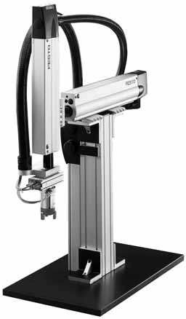

The swivel/linear drive can be used for the positioning of workpieces, for example. The bearing of the piston rod is designed so that it can support high lateral forces. The unit can be mounted in a number of different ways, e.g. with a flange on the front side or with slot nuts, which are in- serted in the linear profile. If required, the energy for the gripper or the suction cup is supplied through the hollow piston rod.

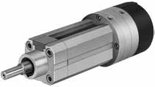

*Festo Didactic • TP101*

*Fig. 6.17*

*Application example with handling modules*

*Swivel/linear drive*

*Fig. 6.18*

*Swivel/linear drive*

# 244

*Chapter B-6*

*Pneumatic grippers*

*Fig. 6.19*

*Pneumatic grippers*

* + 1. *Radial grippers*
    2. *Parallel grippers*
    3. *3-point grippers*
    4. *Angle grippers*

*Vacuum generators*

*Fig. 6.20*

*Vacuum generators*

1. *Flat suction cups*
2. *Bellows suction cups*

Handling equipment must have grippers for picking up, moving and re- leasing the workpiece. Grippers establish either a force-locking or a po- sitive-locking connection with the part.

Figure 6.19 shows different gripper types. All gripper types have a doub- le-acting piston drive and are self-centring. Contactless position sensing is possible with proximity sensors. External gripper fingers make the grippers suitable for a wide variety of applications.

* 1. b) c) d)

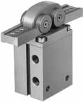 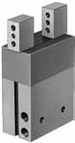 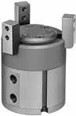 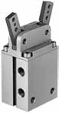

Handling with suction cups is generally a simple, low-cost and reliable solution.

Suction cups allow the handling of different workpieces with weights ranging from a few grammas right up to several hundred kilo grammas. They come in a wide variety of different shapes, such as universal, flat or bellows suction cups, for example.

* + 1. b)

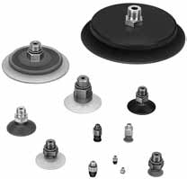 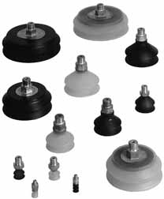

*TP101 • Festo Didactic*

# 245

*Solutions*

Section C

Solutions to the exercises in chapter 5

# 246

*Solutions*

Exercise 1: Direct control of a double-acting cylinder

*Problem definition*



*Fig. 1 Circuit diagram with 5/2-way valve*

A double-acting cylinder is to extend when a push button is operated. Upon release of the push button the cylinder is to retract. The cylinder is of small bore (25 mm diameter) requiring a small flow rate to operate at the correct speed.



# 247

*Solutions*

The following manually operated directional control valves can be used as control elements:

• 5/2-way valve.

• 4/2-way valve

In the initial position, the valve is unactuated, pressure is applied at the piston rod side and the piston rod of the cylinder is retracted.

On operating the push button, the air passes through the valve from 1 to the 4 port and advances the piston rod. The displaced air flows to at- mosphere via the ports 2 and 3. On release of the push button, the valve spring returns the control valve to its initial position and the cylinder re- tracts. Air returns from the cylinder via the exhaust port 5.

The push button is released, the direction of movement is immediately reversed and the piston rod retracts. It is therefore possible to change the direction of movement without the piston rod reaching its initial or end position.



*Solution*

*Fig. 2*

*Circuit diagram with 4/2-way valve*



# 248

*Solutions*

Exercise 2: Indirect control of a double-acting cylinder

*Problem definition*

*Fig. 3 Circuit diagram with 4/2-way valve*



A double-acting cylinder is to advance when a push button is operated. Upon release of the push button the cylinder is to retract. The cylinder is 250 mm in diameter and consumes a large volume of air.







# 249

*Solutions*

For controlling cylinders at high speed or of large diameter, the air flow required determines that a large size control valve should be used. The operating force to actuate the valve may be relatively large and in this case indirect control is preferable.

The valve 1S when operated by a push button supplies a pilot signal to the 14 port of the control valve 1V. The valve 1V reverses, the piston rod of the cylinder is pressurised and the piston rod of cylinder 1A advances. If the push button is released, the control port of valve 1V exhausts to atmosphere. The valve 1V then reverses and the cylinder retracts.

If the push button is released, the direction of movement is immediately reversed and the piston rod retracts. A change in the direction of move- ment is therefore possible without the piston rod reaching its initial or end position. Since the valve 1V is without memory function, it changes its switching position immediately after the push button of valve 1S has been pressed.





*Solution*

*Fig. 4*

*Circuit diagram with 5/2-way valve*





# 250

*Solutions*

Exercise 3: The logic AND function

*Problem definition*

*Fig. 5 Circuit diagram*

The piston rod of cylinder 1A is to advance only if a workpiece is in- serted in the workpiece retainer, a guard has been lowered and the op- erator presses the push button valve. Upon the release of the push but- ton or if the guard is no longer in the lower position, the cylinder 1A is to retract to the initial position.



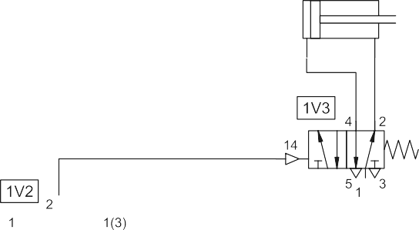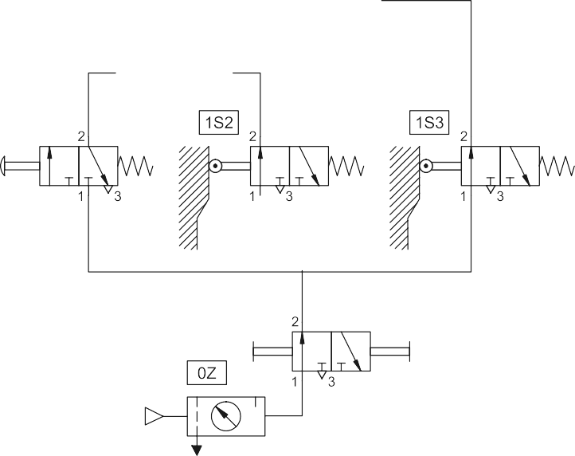

# 251

*Solutions*

The logic AND operation of the output signals of valves 1S1, 1S2 and 1S3 is checked by the dual-pressure valves 1V1 and 1V2.

If the valves are actuated, i.e. 1S2 (via the workpiece), 1S3 (via the guard) and 1S1 (via the operator), a signal is applied at output A of the dual-pressure valve 1V2. This signal is passed on to the control port 14 of the control element 1V3. The valve 1V3 reverses, pressure is applied at the piston side of the cylinder 1A and the piston rod advances.

If the push button is released or the guard opened, this means that the AND conditions are no longer met. The control port 14 of the valve 1V3 is unpressurised. The valve 1V3 switches and the piston rod retracts.

*Solution*

# 252

*Solutions*

Exercise 4: The logic OR function

*Problem definition*

*Fig. 6 Circuit diagram*

A double-acting cylinder is used to transfer parts from a magazine. If either a push button or a footpedal is operated, then the cylinder is to advance. Once the cylinder is fully advanced, it is to retract to the initial position. A 3/2-way roller lever valve is to be used to detect the full ex- tension of the cylinder.





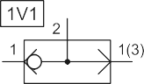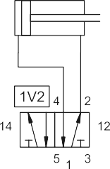

# 253

*Solutions*

The logic OR operation of the ourtput signals of valves 1S1 and 1S2 is checked by the shuttle valve 1V1.

Upon operation of either the push button of valve 1S1 or the pedal of valve 1S2, a signal is generated at the 1 or 1(3) side of the shuttle valve. The OR condition is met and the signal is passed to the control port 14 of the valve 1V2. The valve 1V2 switches, pressure is applied to the pis- ton side of the cylinder 1A, and the cylinder advances.

If the actuation (push button or pedal) of the valve is released, the signal at the control port of valve 1V2 is reset. Since valve 1V2 is a double pilot valve (with memory function), its switching position does not change. The limit swith 1S3 is actuated, when the piston rod reaches its end po- sition. A signal is then applied at the control port 12 of the valve 1V2. The valve 1V2 reverses and the piston rod retracts.

If the limit switch 1S3 is released during retracting, the direction of movement can be changed by actuating the push button or the pedal, even if the piston rod has not yet reached its initial position.

*Solution*

# 254

*Solutions*

Exercise 5: Memory circuit and speed control of a cylinder

*Problem definition*

*Fig. 7 Circuit diagram*



A double-acting cylinder is to be used to transfer parts from a magazine. The cylinder is to fully advance when a push button is operated and then retract automatically. Full extension is confirmed by a roller lever valve. The cylinder is to continue forward even if the push button is released before full extension is reached. The speed of the cylinder is to be ad- justable in both directions of motion.



# 255

*Solutions*

The limit switch 1S2 is actuated, when the piston rod reaches its end position. If the push button 1S1 remains pressed in this status, a rever- sal of the valve 1V1 is not possible, since a signal is applied at both con- trol ports 12 and 14. The first signal applied 14 is dominant. The signal at control port 12 is ineffective. The piston rod remains in the extended status. The piston rod cannot be retracted until the push button 1S1 has been released and the control port 14 becomes unpressurised.

If the roller lever valve 1S2 is fitted at the stroke mid-position, then the piston rod retracts again upon reaching this position. However, this is not possible unless the push button 1S1 has already been released again. If the push button 1S1 has not yet been released at this point, the piston rod overtravels the limit switch 1S2 and travels up to the cylinder stop. A return stroke is not possible unless the roller lever valve has been manually actuated or with the help of the manual override of the control element 1V1.

Both valves 1S1 and 1S2 are unactuated in the initial position. The switching position of the valve 1V1 is such that connections 1 and 2 and connection 4 and 5 are each interconnected. With this, pressure is ap- plied at the piston rod side of the cylinder 1A and the piston rod remains in the retracted status.

If push button 1S1 is actuated, a signal is applied at the input 14 of the valve 1V1. The valve 1V1 switches, pressure is applied at the piston side of the cylinder 1A and the piston rod advances. Upon reaching the end position, the piston rod actuates the limit switch 1S2, and a signal is applied at the control port 12 of the valve 1V1. This reverses and the piston rod retracts.

The speed of the piston rod is set via the adjusting screw on the flow control valves 1V2 and 1V3 (exhaust air flow control).

After each of the valves 1S1 and 1S2 has been released, the control ports become pressureless. The use of a double pilot valve (valve 1V1 has a memory function) ensures that the switching position does not change.

*Answer to question 1*

*Answer to question 2*

*Answer to question 3*

*Answer to question 4*

# 256

*Solutions*

Exercise 6: The quick exhaust valve

*Problem definition*

*Fig. 8 Circuit diagram*

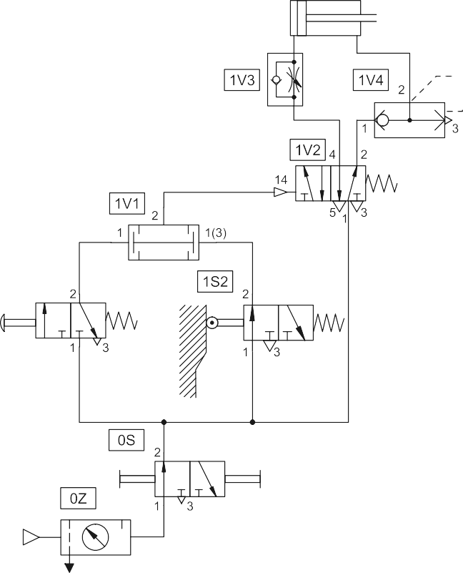

The combined actuation of a manually actuated valve and a roller lever valve advances a forming tool on an edge-folding device. The forming tool is driven by a double-acting cylinder. For rapid forward travel, the circuit utilises a quick exhaust valve. The retracting speed is to be ad- justable. If either of the two valves are released, the tool returns to its initial position.

# 257

*Solutions*

In the initial position, the inserted workpiece actuates the roller lever valve 1S2. The quick exhaust valve 1V4 is closed to atmosphere, pres- sure is applied at the piston rod side of the cylinder 1A, and the piston rod remains in the retracted status.

If the start button 1S1 is actuated, a signal is applied at both inputs 1 and 1(3) of the dual-pressure valve 1V1. The AND condition is met and the signal is passed to the control port 14 of the control element 1V2. The valve 1V2 switches, pressure is applied to the piston side of the cylinder 1A, and the piston rod advances. As a result of the valve 1V2 reversing, input 1 of the quick exhaust valve 1V4 becomes pressureless. The air displaced on the piston rod side of the cylinder during advancing opens the quick exhaust valve and flows directly to atmosphere via the output 3. The flow resistance, created by the valve 1V2 and the lines against the displaced air, no longer applies. The piston rod is able to advance more rapidly.

If one of the two valves 1S1 or 1S2 is released, the AND condition at the dual-pressure valve 1V1 is no longer met. The final control element 1V2 switches, the quick exhaust valve 1V4 closes and the piston rod retracts.

The retracting speed is set at the restrictor of the one-way flow control valve 1V3.

*Solution*

# 258

*Solutions*

*Problem definition*

*Fig. 9 Circuit diagram*

Exercise 7: Pressure dependent control; embossing of plastic components

A plastic component is embossed using a die powered by a double- acting cylinder. The return of the die is to be effected when the cylinder rod has fully extended to the embossing position and the preset pres- sure is reached. A roller lever valve is to be used to confirm full exten- sion. The signal for retracting must only be generated when the piston rod has reached the embossing position. The pressure in the piston chamber is indicated by a pressure gauge.

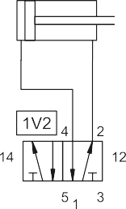





# 259

*Solutions*

In the initial position, valves 1S1 and 1S2 are unactuated, pressure is applied at the piston rod side of the cylinder 1A and the piston rod re- mains in the retracted state. If necessary, the circuit needs to be put into its initial position with the help of the manual override on the control ele- ment 1V2. A signal is applied at the control port 14 of the control ele- ment 1V2, if the push button 1S1 is actuated. The valve 1V2 switches, pressure is applied at the piston side of the cylinder 1A, and the piston rod advances. If the push button 1S1 is released, the switching position of the double pilot valve 1V2 does not change due to its memory func- tion.

Just before reaching the forward end position (embossing position), the limit switch 1S2 is actuated. The actuated roller lever valve 1S2 releases the pressure line 1 to the pressure sequence valve 1V1. During the em- bossing process, the pressure on the piston side starts to increase. The indicator of the pressure gauge turns to the right. When this pressure reaches the value set at the control port 12 of the pressure sequence valve, the 3/2-way valve of the pressure sequence valve switches. The control element 1V2 reverses and the piston rod retracts. During the retracting movement, the limit switch 1S2 is released and the signal at the control port 12 of the valve 1V2 is reset and the pressure sequence valve is also reset.

*Solution*

# 260

*Solutions*

Exercise 8: The time delay valve

*Problem definition*

*Fig. 10 Circuit diagram*



A double-acting cylinder is used to press together glued components. Upon operation of a push button, the clamping cylinder slowly advances. Once the fully extended position is reached, the cylinder is to remain for a time of t1 = 6 seconds and then immediately retract to the initial posi- tion. A new start cycle is only possible after the cylinder has fully re- tracted and after a delay of t2 = 5 seconds. During this delay the finished part is manually removed and replaced with new parts for gluing. The retracting speed is to be rapid, but adjustable.







# 261

*Solutions*

In the initial position, the roller lever valve 1S2 is actuated by the piston rod and the time delay valve 1V1 is switched through, i.e. the working port 2 supplies a signal. The piston rod side of the cylinder 1A is pressurised and the piston rod remains in the retracted state. The following start condition must apply:

* Roller lever valve 1S2 is actuated
* Time delay valve 1V1 is switched through
* Start button is actuated

If the roller lever valve 1S2 is actuated for a sufficiently long time period (t1 = 5 seconds), then the air reservoir of the time delay valve 1V1 is filled and the corresponding 3/2-way valve is switched, following which a signal is applied at input 1(3) of the dual-pressure valve 1V2.

If the push button 1S1 is actuated, the AND condition at the dual- pressure valve is met. A signal is applied at the control port 14 of the control element 1V4. The valve 1V4 switches, pressure is applied to the piston side of the cylinder 1A and the piston rod advances. After a short advancing distance, the limit switch 1S2 is released, pressure is reduced in the air reservoir of the time delay valve 1V1 via the roller lever valve 1S2, and the integrated 3/2-way valve switches back to its initial posi- tion. The AND condition at the dual-pressure valve is now no longer met. Actuation of the push button 1S1 becomes ineffective.

Upon reaching the advancing position, the piston rod actuates the roller lever valve 1S3. The pressure line to the time delay valve 1V3 is now released and pressure in the air reservoir is increased. The rate of pres- sure increase is adjustable via the integrated flow control valve. When the switching pressure has been reached, the integrated 3/2-way valve switches and a signal is applied at the control port 12 of the final control element 1V4. The valve 1V4 reverses and the piston rod retracts. Upon release of the limit switch 1S3, the time delay valve 1V3 switches to its initial position again.

The limit switch 1S2 is actuated, when the piston rod reaches its initial position. The pressure in the air reservoir of the time delay valve 1V1 starts to increase until the switching pressure has been reached after t2 = 5 seconds. The integrated 3/2-way valve switches. The initial status of the system is now reached again and a new cycle can be started.

The piston rod speed is set at the restrictors of the one-way flow control valves 1V5 and 1V6 (exhaust air flow control).

*Solution*

# 262

*Solutions*

# 263

List of standards and references

# 264

*List of Standards*

DIN/EN 292-1 Safety of machinery – Basic concepts, general

principles of design – Part 1: Basic terminology, methodology

DIN/EN 292-2 Safety of machinery – Basic concepts, general

principles of design – Part 2: Technical principles and specifications

DIN/EN 418 Safety of machinery – Emergency stop equipment,

functional aspects – Principles for design

DIN/EN 983 Safety of machinery – Safety requirements for fluid

power systems and their components – Pneumat- ics

DIN/ISO 1219-1 Fluid power systems and components – Graphic

symbols and circuit diagrams – Part 1 and Part 2

ISO/DIS 11727 Pneumatic fluid power – Identification of ports and

control mechanisms of control valves and other components (port designations for pneumatic equipment)

DIN 1343 Reference conditions, standard conditions, stan-

dard volumes, concepts and values DIN 24558 Pneumatic systems, design principles

DIN 40719 Circuit documents (IEC 848 modified); Part 6: Rules for function charts

DIN/EN 60073 Coding of indicating devices and actuators

(VDE 0199) by colours and supplementary means

DIN/EN 60617-8 Graphical symbols for diagrams (IEC 617-8)

Part 8: Measuring instruments, lamps and signal- ling devices

# 274

*Physical values*

|  |  |  |
| --- | --- | --- |
| l | Length | m |
| m | Mass | kg |
| t | Time | s |
| T | Temperature | K |
| F | Force | N |
| A | Area | 2  m |
| V | Volume | 3  m |
| qv | Volumetric flow rate | 3  m /s |
| p | Pressure | bar (Pa) |
| A | Piston surface | 2  m |
| A' | Annular surface | 2  m |
| d | Piston rod diameter | m |
| D | Cylinder diameter | m |
| Feff | Effective piston force | N |
| FF | Force of retract spring | N |
| FR | Friction force | N |
| Fth | Theoretical piston force | N |
| n | Number of strokes per minute | 1/min |
| pabs | Absolute pressure | bar (Pa) |
| pamb | Ambient pressure | bar (Pa) |
| pe | Excess or vacuum pressure | bar (Pa) |
| *∆*p | Differential pressure | bar (Pa) |
| qB | Air consumption | l/min |
| qH qL | Air consumption per cm of stroke Delivery quantity | l/cm  3  m /min |
| qn | Nominal flow rate | l/min |
| s | Stroke length | cm |
| t | Centigrade temperature | °C |
| VB | Reservoir size | 3  m |
| z | Switching cycles per hour | 1/h |
| Tn | Standard temperature | Tn = 273.15 K, tn = 0 °C |
| pn | Standard pressure | pn = 101325 Pa |

*and units*